**ECHO**

**Online Crime Reporting**

*Project Report*

*Submitted by*

**Sudeesh E S**

**Reg. No.: AJC22MCA-2092**

*In Partial fulfillment for the Award of the Degree of*

**MASTER OF COMPUTER APPLICATIONS**

**(MCA TWO YEAR)**

**APJ ABDUL KALAM TECHNOLOGICAL UNIVERSITY**



**AMAL JYOTHI COLLEGE OF ENGINEERING**

**KANJIRAPPALLY**

[Affiliated to APJ Abdul Kalam Technological University, Kerala. Approved by AICTE, Accredited by NAAC. Koovappally, Kanjirappally, Kottayam, Kerala – 686518]

# 2022-2024

## DEPARTMENT OF COMPUTER APPLICATIONS

### AMAL JYOTHI COLLEGE OF ENGINEERING

**KANJIRAPPALLY**



**CERTIFICATE**

This is to certify that the Project report, “**ECHO”** is the bona fide work of **SUDEESH E S** **(Regno:AJC22MCA-2092)** in partial fulfillment of the requirements for the award of the Degree of Integrated Master of Computer Applications under APJ Abdul Kalam Technological University during the year 2023-24.

**Ms. Nimmy Francis Ms. Meera Rose Mathew**

**Internal Guide Coordinator**

**Rev. Fr. Dr. Rubin Thottupurathu Jose External Examiner**

**Head of the Department**



**Department of Computer Applications**

CERTIFICATE ON PLAGIARISM CHECK

|  |  |  |
| --- | --- | --- |
| 1 | Name of the Scholar |  |
| 2 | Title of the Publication |  |
| 3 | Name of the Guide |  |
| 4 | Similar Content (%) identified |  |
| 5 | Acceptable Maximum Limit | **25%** |
| 6 | Software Used | **TURNITIN** |
| 8 | No.of pages verified |  |

*Report on plagiarism check result with % of similarity shall be attached.

Name & Signature of the Scholar: **Sudeesh E S**

Name & Signature of the Guide: **Ms. Nimmy Francis**

Name & Signature of the Head of the Department: **Rev. Fr. Dr. Rubin Thottupurathu Jose**

Dept. Seal

**DECLARATION**

I hereby declare that the project report **“ECHO”** is a bona fide work done at Amal Jyothi College of Engineering, towards the partial fulfilment of the requirements for the award of the Master of Computer Applications (MCA) from APJ Abdul Kalam Technological University, during the academic year 2023-2024.

**Date: SUDEESH E S**

**KANJIRAPPALLY Reg: AJC22MCA-2092**

# ACKNOWLEDGEMENT

First and foremost, I thank God almighty for his eternal love and protection throughout the project. I take this opportunity to express my gratitude to all who helped me in completing this project successfully. It has been said that gratitude is the memory of the heart. I wish to express my sincere gratitude to our Manager **Rev. Fr. Dr. Mathew Paikatt** and Principal

**Dr. Lilly Kutty Jacob** for providing good faculty for guidance.

I owe a great depth of gratitude and appreciation towards our Head of the Department

**Rev.Fr. Dr. Rubin Thottupurathu Jose** for helping us. I extend my whole hearted thanks to the project coordinator **Ms. Meera Rose Mathew** for her valuable suggestions and for overwhelming concern and guidance from the beginning to the end of the project. I would also express sincere gratitude to my guide **Ms. Nimmy Francis** for her inspiration and helping hand.

I thank our beloved teachers for their cooperation and suggestions that helped me throughout the project. I express my thanks to all my friends and classmates for their interest, dedication, and encouragement shown towards the project. I convey my hearty thanks to my family for the moral support, suggestions, and encouragement to make this venture a success.

SUDEESH E S

**CONTENT**

|  |  |  |  |  |
| --- | --- | --- | --- | --- |
| **SL. NO** | | **TOPIC** | **PAGE NO** | |
| **1** | | **INTRODUCTION** | **1** | |
| **1.1** | | **PROJECT OVERVIEW** | **2** | |
| **1.2** | | **PROJECT SPECIFICATION** | **2** | |
| **2** | | **SYSTEM STUDY** | **4** | |
| **2.1** | | **INTRODUCTION** | **5** | |
| **2.2** | | **EXISTING SYSTEM** | **5** | |
| **2.3** | | **DRAWBACKS OF EXISTING SYSTEM** | **6** | |
| **2.4** | | **PROPOSED SYSTEM** | **7** | |
| **2.5** | | **ADVANTAGES OF PROPOSED SYSTEM** | **7** | |
| **3** | | **REQUIREMENT ANALYSIS** | **9** | |
| **3.1** | | **FEASIBILITY STUDY** | **10** | |
| **3.1.1** | | **ECONOMICAL FEASIBILITY** | **10** | |
| **3.1.2** | | **TECHNICAL FEASIBILITY** | **11** | |
| **3.1.3** | | **BEHAVIORAL FEASIBILITY** | **11** | |
| **3.1.4** | | **FEASIBILITY STUDY QUESTIONNAIRE** | **12** | |
| **3.2** | | **SYSTEM SPECIFICATION** | **15** | |
| **3.2.1** | | **HARDWARE SPECIFICATION** | **15** | |
| **3.2.2** | | **SOFTWARE SPECIFICATION** | **15** | |
| **3.3** | | **SOFTWARE DESCRIPTION** | **15** | |
| **3.3.1** | | **PYTHON** | **15** | |
| **3.3.2** | | **DJANGO** | **15** | |
| **3.3.3** | | **SQLITE** | **16** | |
| **4** | | **SYSTEM DESIGN** | **17** | |
| **4.1** | | **INTRODUCTION** | **18** | |
| **4.2** | | **UML DIAGRAM** | **18** | |
| **4.2.1** | | **USE CASE DIAGRAM** | **19** | |
| **4.2.2** | | **SEQUENCE DIAGRAM** | **21** | |
| **4.2.3** | | **STATE CHART DIAGRAM** | **23** | |
| **4.2.4** | | **ACTIVITY DIAGRAM** | **24** | |
| **4.2.5** | | **CLASS DIAGRAM** | **26** | |
| **4.2.6** | | **OBJECT DIAGRAM** | **28** | |
| **4.2.7** | | **COMPONENT DIAGRAM** | **29** | |
| **4.2.8** | | **DEPLOYMENT DIAGRAM** | **31** | |
| **4.2.9** | | **COLLABORATION DIAGRAM** | **33** | |
| **4.3** | | **USER INTERFACE DESIGN USING FIGMA** | **34** | |
| **4.4** | | **DATABASE DESIGN** | **36** | |
| **5** | | **SYSTEM TESTING** | **45** | |
| **5.1** | | **INTRODUCTION** | **46** | |
| **5.2** | | **TEST PLAN** | **46** | |
| **5.2.1** | **UNIT TESTING** | | **47** |
| **5.2.2** | **INTEGRATION TESTING** | | **47** |
| **5.2.3** | **VALIDATION TESTING** | | **48** |
| **5.2.4** | **USER ACCEPTANCE TESTING** | | **48** |
| **5.2.5** | **AUTOMATION TESTING** | | **48** |
| **5.2.6** | **SELENIUM TESTING** | | **49** |
| **6** | **IMPLEMENTATION** | | **65** |
| **6.1** | **INTRODUCTION** | | **66** |
| **6.2** | **IMPLEMENTATION PROCEDURE** | | **66** |
| **6.2.1** | **USER TRAINING** | | **67** |
| **6.2.2** | **TRAINING ON APPLICATION SOFTWARE** | | **67** |
| **6.2.3** | **SYSTEM MAINTENANCE** | | **67** |
| **6.2.4** | **HOSTING** | | **67** |
| **7** | **CONCLUSION & FUTURE SCOPE** | | **71** |
| **7.1** | **CONCLUSION** | | **72** |
| **7.2** | **FUTURE SCOPE** | | **73** |
| **8** | **BIBLIOGRAPHY** | | **74** |
| **9** | **APPENDIX** | | **76** |
| **9.1** | **SAMPLE CODE** | | **77** |
| **9.2** | **SCREEN SHOTS** | | **102** |

## List of Abbreviation

## HTML – Hyper Text Markup Language

## CSS – Cascading Style Sheet

## SQLite – Structured Query Language Lite

## UML – Unified Modelling Language

## JS – JavaScript

## AJAX – Asynchronous JavaScript and XML Environment

## RDBMS _ Relational Database Management System

## IDE _ Integrated Development Environment

## BDD _ Behavioral-Driven Development

## UAT _ User Acceptance Test

## URL _ Uniform Resource Locator

## IP _ Internet Protocol

# CHAPTER 1

# INTRODUCTION

### PROJECT OVERVIEW

In the fast-paced evolution of the job market, the demand for a sophisticated, efficient, and user-friendly platform facilitating the connection between employers and job seekers has become paramount. "ECHO" stands out as an innovative web application built on the Django framework, specifically crafted to tackle the prevailing inefficiencies and challenges within the hiring process. Its central objective is to deliver an enhanced experience for both employers and job seekers, ultimately refining and optimizing the entire recruitment journey.

"ECHO" endeavors to stand as a catalyst for positive transformation, enhancing overall efficiency and satisfaction within the intricate realm of recruitment processes. In its commitment to innovation, "ECHO" seeks to bridge the existing gaps and bottlenecks, providing a seamless interface that facilitates a more intuitive and streamlined interaction between employers and job seekers. Through this advanced yet accessible platform, the aim is not merely to meet industry standards but to set a new benchmark for excellence in recruitment solutions. As the job market continues to evolve, "ECHO" stands poised to redefine and elevate the hiring experience, contributing to a paradigm shift in how employers and job seekers connect and engage throughout the recruitment journey.

### PROJECT SPECIFICATION

The **"ECHO" Crime Reporting System** is meticulously designed, employing a state-of-the-art technology stack. The front-end leverages HTML and CSS to deliver an intuitive user interface, while the back-end relies on Python/Django, ensuring a robust and adaptable foundation.

In the user module, the system prioritizes security with a secure login/logout system and offers profile management features, allowing users to create, modify, and manage their profiles. Anonymity is a key consideration, providing an option for users to submit incidents anonymously.

The admin module equips administrators with essential tools for user account management, employer verification, role definition, and an overview dashboard displaying crucial metrics for effective administration.

The incident reporting module offers a comprehensive reporting form, enabling users to submit detailed incident reports. Multimedia uploads are supported, allowing users to provide additional evidence such as photos and videos. The system also allows users to categorize incidents, facilitating efficient resource allocation.

The job provider module empowers law enforcement by facilitating job posting management, candidate search, and efficient navigation through a user-friendly interface.

The system's architecture seamlessly integrates HTML and CSS for an intuitive user interface, while Python/Django ensures efficient data processing. The inclusion of robust libraries enhances the overall capabilities of the system.

Security is a paramount consideration, with the implementation of secure user authentication and authorization to protect user data and ensure privacy.

User experience is central to the project, emphasizing a user-friendly interface for both the public and law enforcement. Clear navigation and a positive overall experience are key design principles.

Anticipating future developments, **"**ECHO**"** envisions updates that may include advanced features like AI-driven incident categorization or enhanced analytics for better crime prevention.

Rigorous testing procedures cover functionality, security, and user experience, including user acceptance testing. "Echo" aims to be a reliable solution, simplifying and enhancing the crime reporting experience for all users involved.

# CHAPTER 2

# SYSTEM STUDY

### INTRODUCTION

A system study is a critical phase in the lifecycle of any software or organizational project. It is a systematic and structured process of analysing, understanding, and evaluating the existing systems, processes, and technologies within an organization. The primary objective of a system study is to identify inefficiencies, shortcomings, and areas for improvement. This process serves as the foundation for making informed decisions about implementing new systems, software, or process enhancements.

System studies involve a detailed examination of the organization's current operations, which can range from business processes to information systems and technologies in use. The goal is to gain a comprehensive understanding of how the organization operates and how it can be optimized.

### EXISTING SYSTEM

The current crime reporting landscape faces challenges characterized by fragmented reporting processes, data management inefficiencies, and delayed responses from law enforcement agencies. A closer examination exposes gaps in incident documentation, hindering the timely and effective collaboration between the public and law enforcement. Existing systems often lack a unified and systematic approach, resulting in prolonged response times and missed opportunities to address incidents promptly. Despite attempts to modernize, these systems struggle to adapt to the evolving dynamics of crime reporting, contributing to a disconnect between the community and law enforcement. The demand for a more responsive and streamlined system in the crime reporting ecosystem is evident.

**2.2.1 NATURAL SYSTEM STUDIED**

The existing natural system in crime reporting relies heavily on traditional, manual processes, leading to several challenges in effective incident management. Law enforcement agencies often grapple with paper-based documentation, hindering the seamless flow of information and creating data management issues. The reliance on manual reporting by the public results in delays in incident reporting and response times. Additionally, the lack of a unified and automated system contributes to difficulties in tracking and prioritizing reported incidents. The "ECHO" system aims to address these shortcomings by introducing automation and modernizing the crime reporting process. Through streamlined and automated workflows, it seeks to enhance data management, reduce reporting delays, and improve the overall efficiency of incident handling by law enforcement agencies. The goal is to create a more responsive and integrated system.

.

**2.2.2 DESIGNED SYSTEM STUDIED**

In the realm of online crime reporting, various designed systems have been examined, revealing both limitations and advantages. Many existing systems may lack comprehensive features, user-friendly interfaces, and efficient data management practices. The examination of these systems aims to distill effective elements that can be integrated into the proposed "ECHO" system for a more robust solution. Existing designed systems in crime reporting often focus on specific aspects and may overlook the holistic needs of both the public reporting incidents and law enforcement managing these reports. One common issue is the complexity of interfaces, which can pose challenges for users in navigating seamlessly through the reporting process. "ECHO" strives to overcome these challenges by simplifying the user experience, ensuring that technological advancements are harnessed to create an accessible and efficient platform for both the public and law enforcement agencies. The goal is to provide a user-friendly interface that enhances the overall experience of reporting and managing incidents.

Top of Form

### DRAWBACKS OF EXISTING SYSTEM

* Data Management Challenges: The current crime reporting system grapples with data management issues. The extensive information generated, including incident details, evidence, and reports, is often managed through manual and paper-based methods. This reliance can result in errors, inconsistencies, data duplication, and information loss, compromising the overall integrity of the crime data.
* Missed Incident Reports: The existing crime reporting system may not effectively reach individuals who witness or experience criminal activities but choose not to actively report them. Additionally, the system might struggle to keep track of reported incidents that require further follow-up or investigation, leading to missed opportunities in addressing potential criminal activities.
* Manual Screening and Review: Human intervention is often necessary in the screening and review process of reported incidents. This manual approach, undertaken by law enforcement or administrative staff, can be time-consuming, tedious, and subjective. This manual screening may result in overlooked or delayed assessments of the severity and urgency of reported incidents.
* Inefficient Communication Channels: Communication between the public reporting incidents and law enforcement within the existing system may lack a centralized and streamlined approach. This can result in delays, misunderstandings, and a lack of transparency, making it challenging for both the public and law enforcement agencies to stay informed about the progress and resolution of reported incidents. Improved communication channels are essential to enhance the effectiveness of the crime reporting and resolution process

### PROPOSED SYSTEM

The Online Crime Reporting System using Python Django is a web-based platform designed to empower individuals to report criminal activities and incidents in a convenient and efficient manner. This project aims to bridge the gap between the general public and law enforcement in Kottayam district, ensuring a seamless process for reporting and addressing crimes. The system provides an easy-to-use interface where users can submit detailed information about criminal incidents, suspicious activities, or safety concerns. The system offers several key features, including user registration and management, and administrative interfaces for Admin. Upon registration, users can log in securely and submit comprehensive details related to the incident, such as location, time, descriptions, and even multimedia evidence like photos. These reports are then stored in a centralized database, ensuring data integrity and easy access. The admin is equipped with a dedicated administrative panel where they can review, prioritize, and manage reported incidents.

### ADVANTAGES OF PROPOSED SYSTEM

### Streamlined Reporting Process: The "Echo" system simplifies the crime reporting process by providing an intuitive and user-friendly interface. Citizens can easily document incidents, upload relevant evidence like photos or videos, and submit reports with minimal effort. This streamlined process reduces the barriers to reporting, encouraging more people to report criminal activities promptly.

### Faster Response Time: By automating and optimizing the incident documentation and reporting process, "Echo" significantly reduces response times for law enforcement agencies. With real-time incident alerts and streamlined data collection, law enforcement can quickly assess and prioritize incidents, dispatching resources more efficiently and effectively to address urgent situations.

### Enhanced Collaboration Between Public and Law Enforcement: "Echo" fosters better collaboration and communication between the public and law enforcement agencies. The system allows for two-way communication, enabling law enforcement to request additional information or updates from the reporter, and citizens to receive updates on the status of their reports. This collaborative approach builds trust and strengthens community-police relationships.

### Data-Driven Insights for Decision Making: With a robust back-end infrastructure, "Echo" collects and analyzes data from reported incidents, providing law enforcement agencies with valuable insights and trends. This data-driven approach enables agencies to make informed decisions, allocate resources more effectively, and implement targeted crime prevention strategies based on real-time data and analytics.

### Safer and More Connected Community: Ultimately, "Echo" contributes to creating a safer and more connected community by empowering citizens to actively participate in crime prevention and law enforcement efforts. By making the reporting process more accessible and efficient, and by fostering collaboration between the public and law enforcement, "Echo" helps build a community where residents feel safer, more informed, and more engaged in creating a secure environment for everyone. By leveraging modern technology and innovative approaches, "Echo" aims to establish a new standard for crime reporting and law enforcement collaboration, paving the way for safer communities and more efficient law enforcement operations.

# CHAPTER 3

# REQUIREMENT ANALYSIS

## FEASIBILITY STUDY

Feasibility is defined as the practical extent to which a project can be performed successfully.

To evaluate feasibility, a feasibility study is performed, which determines whether the solution

considered to accomplish the requirements is practical and workable in the software.

Information such as resource availability, cost estimation for software development, benefits

of the software to the organization after it is developed and cost to be incurred on its

maintenance is considered during the feasibility study. The results of the feasibility study

should be a report that recommends whether it is worth carrying on with the requirements

engineering and system development process.

The objective of the feasibility study is to establish the reasons for developing the software that

is acceptable to users, adaptable to change and conformable to established standards.

Various other objectives of feasibility study are listed below.

* To analyses whether the software will meet organizational requirements.
* To determine whether the software can be integrated with other existing software.

### Economic Feasibility

Economic feasibility refers to the ability of a project or business venture to generate enough

revenue to cover its costs and provide a reasonable return on investment. It involves analyzing

the costs and benefits of a project, including the costs of materials, labor, and equipment, as

well as the projected revenue from sales or other sources of income. Economic feasibility is an

important consideration when determining whether a project or venture should be undertaken,

and it is often used in conjunction with other types of feasibility analysis, such as technical

feasibility and operational feasibility.

An extensive analysis of the project's financial viability is necessary to determine its economic

viability. This comprises making an initial expenditure estimate for the creation of a website,

the integration of a payment gateway, and marketing initiatives. To assess the project's viability,

it is crucial to predict the running costs, which include maintenance, server hosting, and

customer support. Assessing possible revenue streams, such as product sales, advertising, and

fees from outside vendors, can be done by performing a cost-benefit analysis.

### Technical Feasibility

A Technical Feasibility Study is an essential assessment conducted to evaluate the practicality

and viability of a proposed project from a technological standpoint. It aims to determine

whether the project's implementation is technically feasible and can be executed using available

technology, resources, and expertise. The study involves a comprehensive analysis of the

project's technical requirements, including infrastructure, software, hardware, programming

languages, and integration capabilities. Ultimately, the Technical Feasibility Study serves as a

foundation for effective project planning and ensures that the proposed initiative can be

realistically implemented using available technical resources and expertise.

Personalized Online Gift Store project's technical feasibility points cover several important

factors. First, the front-end and back-end development of the website should make use of the

right programming languages and frameworks. Given the utilization of cloud hosting services

and load balancing techniques, scalability is crucial to support possible expansion in user traffic

and data. For a seamless user experience across many devices, mobile responsiveness is

essential. Database management should reliably and securely handle user data, order

information, and product information. Integrating a secure payment channel is essential for

safeguarding sensitive user data. For seamless and safe transactions, payment gateway

integration should include dependable alternatives supporting multiple payment methods.

### Behavioral Feasibility

Behavioral feasibility refers to the analysis and assessment of whether the proposed project

or system is acceptable and practical from the perspective of its intended users and

stakeholders. It focuses on understanding and predicting how individuals and groups will

respond to and interact with the project, considering their attitudes, preferences, behavior, and

willingness to adopt and use the system. Behavioral feasibility aims to identify potential

barriers, resistance, or challenges that might arise during the implementation and operation of

the project, and it seeks to ensure that the project aligns with the needs and expectations of its

target audience.

Examining the platform's acceptance and usability by its target users is one of the behavioral

feasibility criteria in personalized online gift shop. To learn more about what customers want,

need, and anticipate from an online gift shop, you can conduct user surveys or focus groups.

The platform's functionality and design can be tailored to the preferences of users by

considering their behavior and adoption trends. To make sure that users have a seamless and

satisfying experience, user training and onboarding resources may be required. You may

increase your online gift shop's chances of success and customer happiness by assessing the

behavioral factors and making sure it is user-friendly, interesting, and caters to the needs of

its target markets.

**3.1.4 Feasibility Study Questionnaire**

**Project Overview:**

The Project entitled “Online Crime Reporting System” aims to enhance the efficiency and transparency of crime reporting and investigation processes. It facilitates the entire crime management lifecycle, from reporting incidents to case resolution, providing a seamless experience for law enforcement, administrators, and the public.

**To What Extent the System is Proposed For:**

The proposed system is primarily designed for law enforcement agencies, officers, and the general public. It empowers citizens to report crimes, assists law enforcement in managing cases, and provides administrators with tools to oversee the system effectively.

**Specify the Viewers/Public Involved in the System:**

The viewers/public involved in the system include administrators, users, visitors.

List of Modules Included in the System:

1. Administrator Module
2. User Module
3. Visitor Module
4. Law Enforcement

**Q: What challenges are you currently facing in managing criminal incidents that this system aims to address?**

A: Our current crime management processes lack efficiency and transparency. We struggle with the timely reporting of incidents, coordination among law enforcement agencies, and maintaining a comprehensive database of criminal activities.

**Q: How is user authentication and authorization currently managed within your law enforcement operations?**

**A:** User authentication primarily relies on secure access credentials. We must ensure secure user authentication by utilizing robust authentication systems and following security best practices to protect sensitive data.

**Q: Could you describe the types of crimes and incidents you handle, and how are they currently managed?**

**A:** We handle a wide range of criminal activities. Currently, these incidents are managed through manual reporting, paper documentation, and legacy systems. There is a need for a centralized system to streamline incident reporting, investigation, and case management.

**Q: How do you currently monitor the performance of your law enforcement operations, including case resolution and public satisfaction?**

**A:** Performance monitoring is currently decentralized, making it challenging to assess the overall effectiveness of our operations. We lack a centralized dashboard for real-time insights. The system aims to implement performance tracking and feedback mechanisms to enhance operations.

**Q: Are there any machine learning or analytics features you envision for this crime reporting system?**

**A:** While not a primary focus, we see potential for machine learning modules to enhance crime pattern recognition, suspect identification, and predictive policing. These capabilities could improve the efficiency of our crime management processes.

**Q: What is the expected timeline for implementing the crime reporting system?**

**A:** We anticipate that the implementation of the system will take around 12-18 months, considering the complexity of integrating with existing systems and ensuring data security.

**Q: What budget considerations are there for this project?**

**A**: We have allocated a budget that includes software development costs, hardware infrastructure, security measures, training, and ongoing operational expenses.

**Q: Do you have any specific security and privacy requirements for sensitive crime data, ensuring compliance with data protection regulations?**

**A:** Yes, we have stringent security and privacy requirements to protect sensitive crime data, including encryption, access controls, and compliance with relevant data protection regulations.

**Q: Are there any existing software or systems that need to be integrated with this crime reporting system?**

**A:** Yes, we have existing systems for criminal records, evidence management, and incident reporting that need to be integrated with the new crime reporting system for seamless data exchange and efficiency.

## SYSTEM SPECIFICATION

### Hardware Specification

Processor - 11th Gen Intel(R) Core(TM) i5-1135G7 @ 2.40GHz 2.42 GHz

RAM - 8.00 GB

SSD - 512 GB

### Software Specification

Front End - HTML, CSS

Back End - Python, Django

Database - SQLite

Client on PC - Windows 7 and above.

Technologies used - JS, HTML5, AJAX, J Query, PHP, CSS

## SOFTWARE DESCRIPTION

### Python

Python is a versatile and widely used programming language, prized for its readability and ease of use. Its simple syntax and extensive library support, including frameworks like Django and Flask, expedite development. Python finds applications across web development, data analysis, machine learning, and more. Its platform independence and scalability make it suitable for various operating systems and evolving project needs. In the proposed system, Python forms the foundation for backend development, core functionality, data processing, and integration with different tools and frameworks, enabling the creation of an efficient online platform for purchasing gifts.

**3.3.2 Django**

Django is a high-level Python web framework known for its simplicity and efficiency in web application development. It follows the "batteries-included" philosophy, offering a wide range of built-in features and tools that empower developers to create robust, scalable, and secure web applications. Django promotes the DRY (Don't Repeat Yourself) principle, making it easy to build complex applications with clean, maintainable code. It includes an Object-Relational Mapping (ORM) system for database interactions, a templating engine for designing user interfaces, and a secure authentication system. Django's built-in admin interface simplifies content management and data handling. With a strong community, extensive documentation, and a rich ecosystem of third-party packages, Django remains a top choice for web developers aiming to streamline the development process and deliver high-quality web applications.

**3.3.3 SQLite**

SQLite is a lightweight and self-contained relational database management system. It's known for its simplicity, speed, and ease of integration, making it a popular choice for embedded systems and applications. SQLite operates without a separate server process and allows direct access to the database using a simple and efficient query language. It's ideal for small to medium-sized applications, especially those that need a local data store. In the proposed system, SQLite serves as the backend database, efficiently managing and storing essential data related to home appliances, user accounts, transactions, and more, ensuring a seamless and reliable user experience.

* Self-Contained: SQLite is a self-contained DBMS, meaning it doesn't require a separate server process. The entire database is stored in a single file on the disk.
* Zero Configuration: Unlike many other database systems, SQLite requires minimal to no configuration. You can start using it by just including the library in your project.
* Serverless Architecture: It operates without a central server, allowing applications to access the database directly, simplifying setup and reducing latency.
* ACID Compliant: SQLite ensures data reliability through ACID (Atomicity, Consistency, Isolation, Durability) compliance, guaranteeing that transactions are processed reliably.

# CHAPTER 4

# SYSTEM DESIGN

* 1. **INTRODUCTION**

System design is a critical phase in the software development process, serving as the bridge between high-level requirements and actual implementation. It involves the detailed planning, structuring, and specification of a software system's architecture, components, and functionalities. The primary goal of system design is to transform the abstract concepts and ideas gathered during the requirements analysis phase into a concrete, well-defined blueprint for building the software.

Effective system design is crucial for the successful development and deployment of software systems. It minimizes the risk of misunderstandings, errors, and costly revisions by providing a clear and comprehensive plan that guides the development team throughout the implementation phase.

## UML DIAGRAM

A UML (Unified Modeling Language) diagram is a graphical representation used in software engineering and other fields to visualize, model, and communicate various aspects of a system, such as its structure, behavior, and interactions. UML diagrams provide a standardized and universally accepted way to convey complex system designs. There are several types of UML diagrams, each serving a specific purpose.

* Class Diagram
* Object Diagram
* Use case Diagram
* Sequence Diagram
* Collaboration Diagram
* Activity Diagram
* State Chart Diagram
* Deployment Diagram
* Component Diagram

## USE CASE DIAGRAM

A use case diagram is a type of Unified Modelling Language (UML) diagram that is used to visually represent the functional requirements of a system or software application from the perspective of its users. It provides a high-level view of how a system interacts with its various actors (users, other systems, or external entities) to accomplish specific tasks or functions. Use case diagrams are often employed in the early stages of software development to help define and understand the system's behaviour and its interactions with external elements. Here are some key components and concepts associated with use case diagrams:

* **Actors:** Actors are external entities that interact with the system or software. They can be individuals, other systems, or even hardware devices. Actors are depicted as stick figures or other simple shapes. They are not part of the system but have specific roles or responsibilities in the system's functionality.
* **Use Cases:** Use cases represent specific tasks or functions that the system performs to achieve a particular goal or objective. They describe the system's behaviour in response to a user's or actor's interaction. Use cases are typically represented as ovals. Each use case has a name that describes the specific functionality, such as "Create Account" or "Place Order."
* **Relationships:**
  + Association: A solid line connecting an actor to a use case indicates that the actor interacts with that use case.
  + Inclusion: A dashed line with an arrow pointing to an included use case indicates that one use case includes or invokes another use case. This helps in avoiding redundancy by reusing common functionality.
  + Extension: A dashed line with an arrow pointing to an extended use case indicates that one use case can be extended by another use case under certain conditions. This is used to show optional or alternative behaviour.
* **System Boundary:** The use case diagram typically includes a system boundary, represented as a rectangle that encloses all the use cases and actors. It defines the scope of the system under consideration.
* **Multiplicity Notation:** Sometimes, you can use multiplicity notation to show how many instances of an actor or use case are involved in a particular interaction.

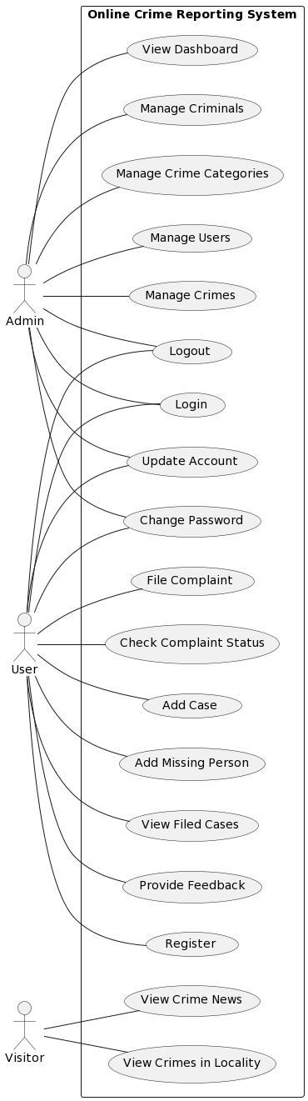

*Fig 1: Use case diagram for Echo*

## 4.2.2 SEQUENCE DIAGRAM

A sequence diagram is a type of Unified Modelling Language (UML) diagram that illustrates the interactions and order of messages between objects or components in a system, showing how they collaborate and work together over time. Sequence diagrams are particularly useful for visualizing and understanding the dynamic behaviour of a system, especially during the execution of specific use cases or scenarios. Here are the key elements and concepts associated with sequence diagrams:

* **Lifelines**: Lifelines represent objects or components participating in the sequence of interactions. Each lifeline is depicted as a vertical dashed line. It typically corresponds to a class or instance of a class in object-oriented design. The lifeline's name or label indicates the object or component it represents.
* **Messages**: Messages are arrows that indicate the flow of communication or interaction between lifelines. They show the order and direction of the interactions. There are two main types of messages:
  + **Synchronous Messages**: These are shown as solid arrows and represent a direct, synchronous call between objects. The sender waits for a response from the receiver before continuing.
  + **Asynchronous Messages**: These are shown as dashed arrows and represent an asynchronous call where the sender does not wait for a response from the receiver. It indicates that the sender sends a message and continues its work without waiting.
* **Activation Bars**: Activation bars represent the period during which an object or component is actively processing a message or is in focus. They are shown as horizontal lines extending from the lifelines, indicating when an object is busy or "activated" by a particular message.
* **Return Messages**: Return messages are used to represent the return or response from a method call. They connect the activation bar of the called object to the activation bar of the calling object.
* **Found Messages**: These messages represent the creation of an object or its appearance in the system. They are often used to illustrate the creation of new instances.
* **Notes**: Notes or comments can be added to provide additional information or explanations about the interactions or specific elements in the diagram.

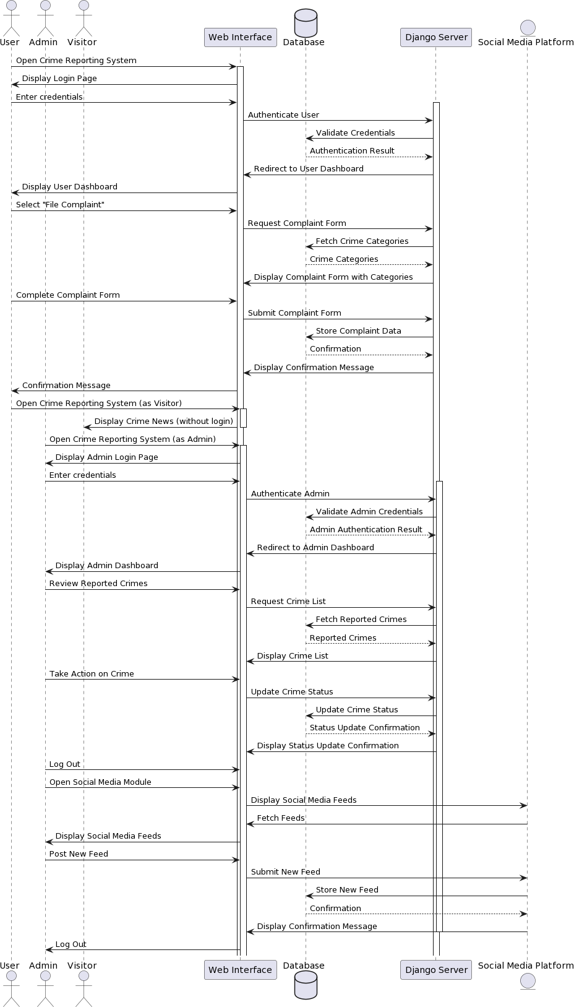

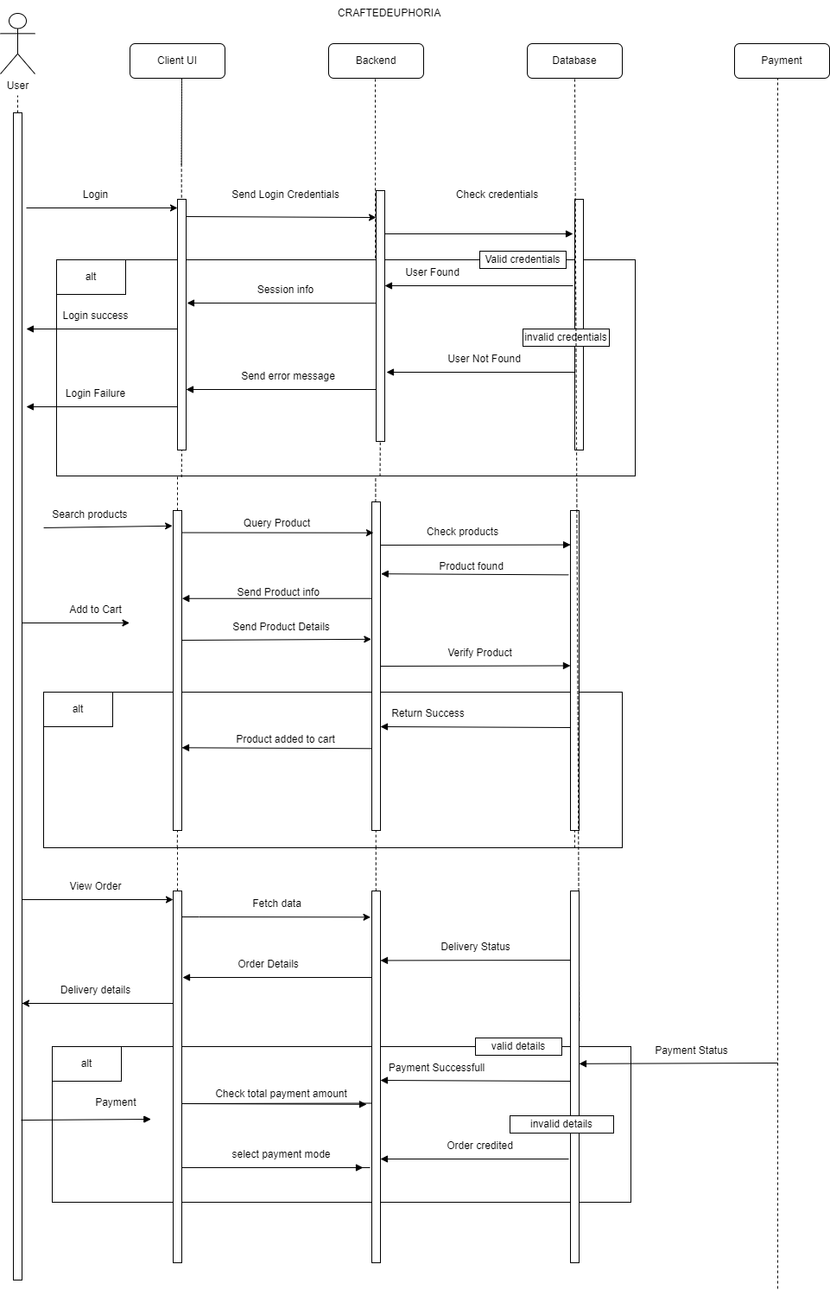Top of Form

*Fig 2: Sequence diagram for Echo*

## 4.2.3 State Chart Diagram

A state chart diagram, also known as a state machine diagram, is a type of Unified Modeling Language (UML) diagram used to depict the various states that an object or system can be in and the transitions between those states. It is particularly useful for modelling the dynamic behaviour of a system over time and in response to specific events or conditions. Here are the key components and concepts associated with state chart diagrams:

* **States**: A state represents a specific condition or situation that an object or system can be in. States are typically depicted as rectangles with rounded corners and labelled with a name, such as "Idle," "Active," or "Error."
* **Transitions**: Transitions are arrows that show how an object or system moves from one state to another in response to an event, condition, or action. Transitions can be labeled with the triggering event or condition that causes the transition, and they often include guard conditions that must be satisfied for the transition to occur.
* **Events**: Events are occurrences or stimuli that trigger transitions between states. These can include user actions, system events, or the passage of time. Events are represented as ovals and labeled with names like "Start," "Stop," or "Button Click."
* **Initial State**: An initial state (usually represented by a filled black circle) shows the state from which the object or system begins its life cycle when it is first created or initialized.
* **Final State**: A final state (usually represented by a circle with a dot inside) indicates the termination or completion of the object's or system's life cycle.
* **Concurrent States**: State chart diagrams can depict concurrent states, where multiple states can be active at the same time. This is useful for modeling systems that have parallel processes or activities.

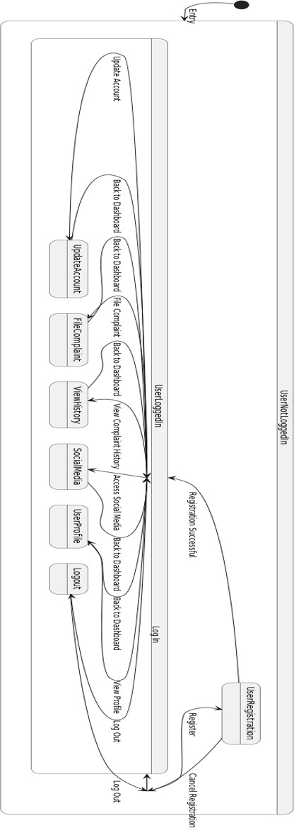

## 4.2.4 Activity Diagram

An activity diagram is a type of Unified Modeling Language (UML) diagram that visualizes the workflow or business processes within a system or a specific use case. It is particularly useful for representing the sequential and parallel activities, actions, decisions, and control flows that make up a complex process or algorithm. Here are the key components and concepts associated with activity diagrams:

* **Activity**: An activity is a specific task or operation within the system. It is represented as a rounded rectangle with a label, such as "Process Order" or "Validate User."
* **Initial Node**: The initial node is a small solid circle that indicates the starting point of the activity diagram. It shows where the process begins.
* **Final Node**: The final node is a solid circle with a dot inside that indicates the endpoint or completion of the process.
* **Action**: An action represents a specific operation or task that is performed within the workflow. Actions are typically depicted as rectangles with rounded corners.
* **Control Flow**: Control flows are arrows that show the sequence of activities or actions within the diagram. They connect the activities and indicate the order in which they are performed.
* **Decision Node**: A decision node is a diamond-shaped symbol used to represent a point in the process where a decision or choice must be made. It typically has multiple outgoing control flows, each associated with a different condition.
* **Merge Node**: A merge node is used to bring multiple control flows back together into a single flow after a decision or branching point.
* **Fork Node**: A fork node, represented as a black bar, is used to indicate that multiple actions or activities can be performed in parallel.
* **Join Node**: A join node, represented as a white bar, is used to show where parallel flows converge into a single flow.

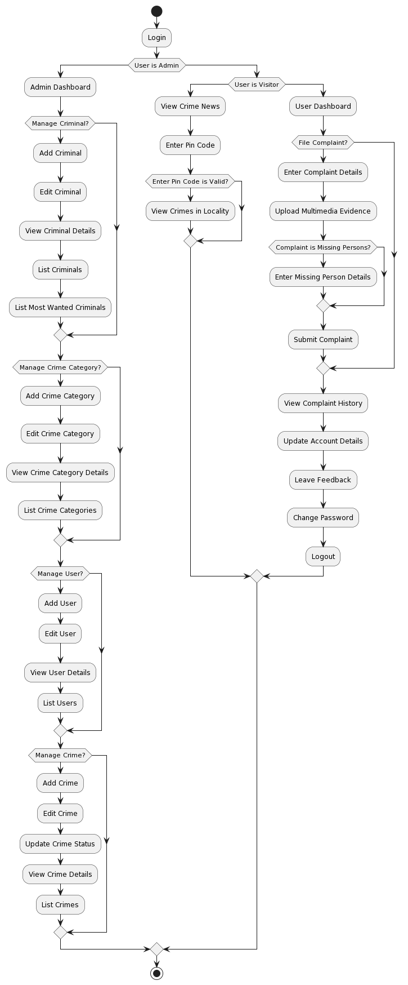



*Fig 4: Activity diagram for Echo*

## 4.2.5 Class Diagram

A class diagram is a type of Unified Modeling Language (UML) diagram used to visualize and represent the static structure of a system or software application. It primarily focuses on the classes, objects, relationships, and attributes that make up the system, offering a clear and organized way to model the system's structure. Here are the key components and concepts associated with class diagrams:

* **Class**: A class is a blueprint or template for creating objects. It defines the properties (attributes) and behaviors (methods) that objects of that class will have. Classes are typically represented as rectangles with three compartments: the top compartment contains the class name, the middle compartment lists the attributes, and the bottom compartment lists the methods.
* **Object**: An object is an instance of a class. It represents a specific real-world entity or concept within the system. Objects are typically not shown in class diagrams but are derived from classes at runtime.
* **Attributes**: Attributes are the characteristics or properties of a class. They describe the data that an object of the class will hold. Attributes are typically listed in the middle compartment of the class rectangle and may include data types and visibility (e.g., public, private, protected).
* **Methods**: Methods represent the behaviors or operations that an object of the class can perform. They are typically listed in the bottom compartment of the class rectangle and include the method name, parameters, return type, and visibility.
* **Associations**: Associations represent the relationships between classes. They indicate how classes are related or connected. Associations can have names, multiplicities (e.g., one-to-one, one-to-many), and roles to specify the nature of the relationship.
* **Aggregation and Composition**: These are special types of associations that represent part-whole relationships. Aggregation represents a "whole-part" relationship, while composition indicates a stronger "exclusive ownership" relationship.
* **Generalization/Inheritance**: Generalization represents the inheritance relationship between classes. It indicates that one class (the subclass or child class) inherits attributes and behaviors from another class (the superclass or parent class).
* **Interfaces**: Interfaces define a contract for a group of classes. They specify a set of methods that classes implementing the interface must provide. Interfaces are represented as a dashed line with a triangle at one end.
* **Dependency**: Dependency is a weaker relationship between classes. It indicates that one class uses or depends on another class without a structural relationship.

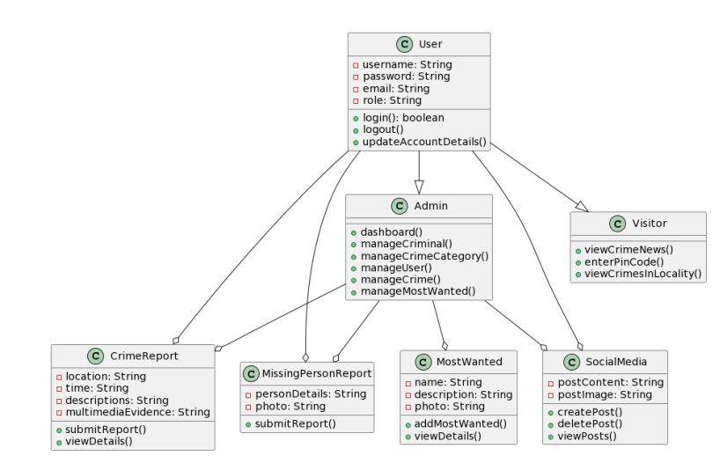

*Fig 5: Class diagram for Echo*

## 4.2.6 Object Diagram

An object diagram is a type of Unified Modeling Language (UML) diagram that provides a snapshot of a specific system or a part of it at a particular moment in time. It visualizes the instances (objects) of classes and the relationships between them, offering a detailed view of the system's structure and the state of objects at a specific point in its execution. Here are the key components and concepts associated with object diagrams:

* **Object**: An object represents an instance of a class at a specific moment in time. It carries the values of the class's attributes and is depicted as a rectangle with the object name followed by a colon and the class name (e.g., "myObject: MyClass"). The object may have underlined attributes to show their values.
* **Class**: A class is a blueprint for creating objects. Objects in an object diagram are instances of classes.
* **Attributes**: Attributes represent the properties or data members of a class. They define the characteristics or state of objects.
* **Relationships**: Object diagrams can depict the relationships between objects, such as associations, aggregations, compositions, or dependencies. These relationships illustrate how objects are related to each other.
* **Links**: Links are lines connecting objects in the diagram to represent relationships between them. These links show how instances of different classes are connected.

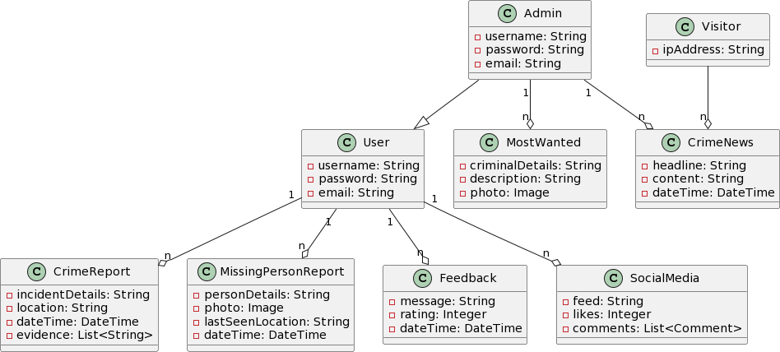

*Fig 6: Object Diagram for CraftedEuphoria*

## 4.2.7 Component Diagram

## A component diagram is a type of Unified Modeling Language (UML) diagram used to depict the physical components and their relationships in a system or software application. It focuses on the high-level structure of the system, illustrating how different components interact and collaborate to provide the system's functionality. Here are the key components and concepts associated with component diagrams:

## Component: A component is a modular, reusable, and replaceable part of a system or software application. Components can be software modules, libraries, executable files, hardware devices, or any other physical or logical unit that contributes to the system's functionality. Components are represented as rectangles with the component name inside.

## Interface: Interfaces define a contract specifying a set of methods or services that a component exposes to the outside world. They allow components to interact with one another through well-defined communication points. Interfaces are depicted as small rectangles with the interface name and a lollipop-like connector.

## Port: Ports are connection points on a component where interfaces can be attached. They represent how a component communicates with the external environment or with other components. Ports are typically small squares located on the sides of a component and are connected to interfaces.

## Dependency: A dependency is a relationship between two components that indicates that one component relies on the functionality provided by another component. Dependencies are often represented as dashed arrows.

## Provided and Required Interfaces: Provided interfaces indicate the interfaces offered by a component, while required interfaces specify the interfaces that the component depends on or requires to function properly.

## 

*Fig 7: Component Diagram*

**4.2.8 Deployment Diagram**

A deployment diagram is a type of Unified Modeling Language (UML) diagram used to visualize the physical deployment of software components and hardware nodes in a system. It provides a clear and detailed representation of how software components are distributed across various hardware elements such as servers, devices, and networks. Deployment diagrams are particularly useful for understanding the system's deployment architecture, including how software is hosted and how different components interact with each other. Here are the key components and concepts associated with deployment diagrams:

* **Nodes:** Nodes represent the hardware elements or computing devices in the system. These can include physical servers, virtual machines, workstations, routers, or other hardware components. Nodes are depicted as rectangles with the name of the hardware element or device.
* **Artifacts:** Artifacts are instances of software components that are deployed on nodes. They represent executable files, libraries, configuration files, and other software elements that are distributed across the hardware. Artifacts are depicted as rectangles or ellipses and are typically connected to the nodes on which they are deployed.
* **Deployed Artifact:** A line with an arrow connecting an artifact to a node represents the deployment of that artifact on the node. It indicates which software components are running on specific hardware.
* **Relationships:** Deployment diagrams can show various relationships between nodes, such as associations, dependencies, and generalization relationships. These relationships can help define how nodes interact with each other.
* **Communication Path:** Communication paths, represented as lines with arrows, illustrate how nodes are connected and communicate with each other through networks or other means.
* **Stereo Types:** Deployment diagrams can use stereo types to provide additional information about nodes and artifacts. For example, you can use "<<web server>>" to indicate that a node is a web server.

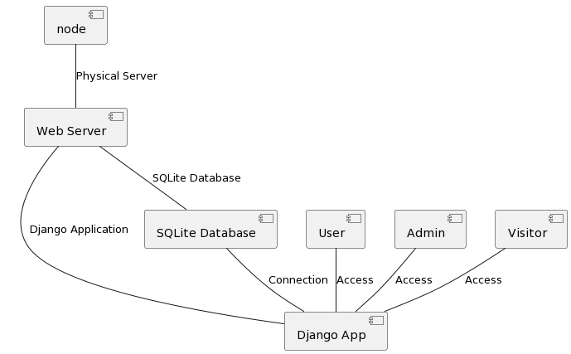

*Fig 8: Deployment Diagram*

**4.2.9 Collaboration Diagram**

A collaboration diagram, also known as a communication diagram, is an illustration of the relationships and interactions among software [objects](https://www.techtarget.com/searchapparchitecture/definition/object) in the Unified Modeling Language ([UML](https://www.techtarget.com/searchsoftwarequality/definition/Unified-Modeling-Language)). Developers can use these diagrams to portray the dynamic behaviour of a particular [use case](https://www.techtarget.com/searchsoftwarequality/definition/use-case) and define the role of each object. To create a collaboration diagram, first identify the structural elements required to carry out the functionality of an interaction. Then build a model using the relationships between those elements. Several vendors offer software for creating and editing collaboration diagrams.

## 4.3 USER INTERFACE DESIGN USING FIGMA

**Form Name: Registration Page**

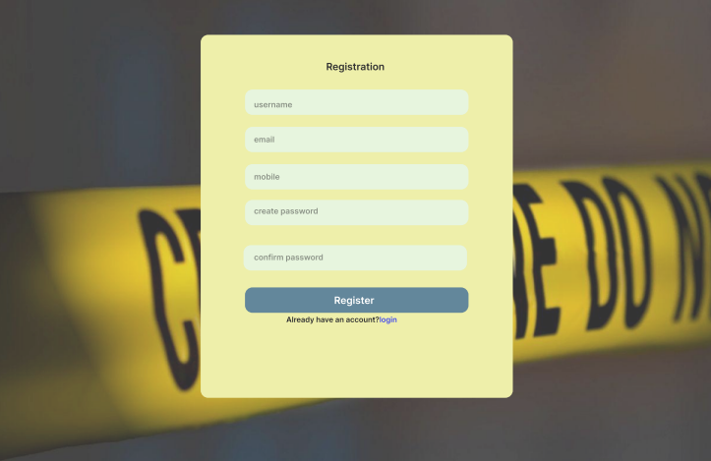

**Form Name: Login Page**

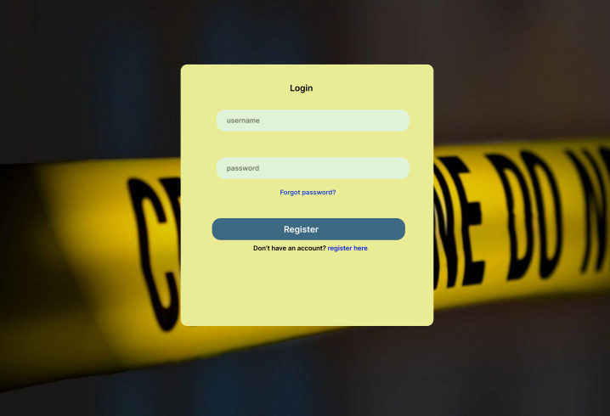

**Form Name: Home Page**



## 4.4 DATABASE DESIGN

## A database is an organized collection of information that's organized to enable easy accessibility, administration, and overhauls. The security of information could be an essential objective of any database. The database design process comprises of two stages. In the first stage, user requirements are gathered to create a database that meets those requirements as clearly as possible. This is known as information-level design and is carried out independently of any DBMS. In the second stage, the design is converted from an information-level design to a specific DBMS design that will be used to construct the system. This stage is known as physical-level design, where the characteristics of the specific DBMS are considered. Alongside system design, there is also database design, which aims to achieve two main goals: data integrity and data independence.

### 4.4.1 Relational Database Management System (RDBMS)

A Relational Database Management System (RDBMS) is a powerful tool for organizing and managing structured data. In the RDBMS model, data is stored in tables with rows and columns, and these tables can be related to one another through primary and foreign keys, enabling data integrity and efficient retrieval. RDBMS systems follow the ACID properties to ensure data consistency and reliability, even in the event of system failures. They use SQL as the standard language for data manipulation and querying.

RDBMS systems support features like indexes for optimizing query performance, normalization for data organization, and the ability to define triggers, stored procedures, and views for custom data handling and business logic. These systems find extensive use in applications where data integrity and structured organization are paramount, such as enterprise databases, e-commerce platforms, and content management systems, with popular RDBMS products like Oracle, MySQL, Microsoft SQL Server, PostgreSQL, and SQLite providing robust solution.

### 4.4.2 Normalization

Normalization is a database design process used to minimize data redundancy and improve data integrity in relational database management systems (RDBMS). It involves organizing data into structured tables to reduce the chances of anomalies during data manipulation and retrieval. The primary goals of normalization are to:

1. Eliminate Data Redundancy: By organizing data efficiently, normalization reduces duplication of data within a database. This minimizes storage requirements and ensures that data remains consistent.
2. Ensure Data Integrity: Normalization enforces rules and constraints that maintain data integrity. It helps prevent anomalies such as update anomalies, insertion anomalies, and deletion anomalies, which can occur when data is not properly structured.

Normalization typically involves breaking large tables into smaller, related tables, ensuring that each table has a clear, well-defined purpose. It is achieved through a series of normal forms (e.g., First Normal Form, Second Normal Form, Third Normal Form) that progressively improve the organization and structure of the database. The specific normal forms address issues like partial dependencies, transitive dependencies, and other data integrity concerns, ultimately resulting in a well-structured and efficient database schema.

**First Normal Form (1NF):** The initial step mandates that each attribute within a table must contain

atomic, indivisible values. It disallows nested relations or relations within relations as attribute

values within tuples. To meet 1NF, data is segregated into separate tables with similar data types,

and each table should have a primary key or foreign key as required. This process eradicates

repeating groups of data and necessitates that each relation conforms to constraints containing the

primary key exclusively.

In the above-taken example of the Retail_Outlets table, we have stored multiple values in an address

field, such as street name, city name, and pin code. A multi-valued attribute is an attribute that can

have multiple values like Contact numbers. They should also be separated like ContactNo1,

ContanctNo2,.. to achieve 1st Normal form.

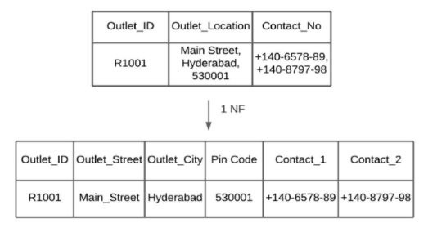

**Second Normal Form (2NF):** The second normal form dictates that non-key attributes should not

be functionally dependent on just a part of the primary key in a relation with a composite primary

key. Instead, they should depend on the entire primary key. Achieving this involves table

decomposition and the creation of new relationships for subkeys and their dependent attributes

while preserving ties with the original primary key. A relation attains 2NF status if it complies

with 1NF conditions for the primary key and exhibits full functional dependence on the primary

key.

In the Retail Outlets table, the Item_Code and Retail_Outlet_ID are key attributes. The item

description is partially dependent on Item_Code only. Outlet_Location depends on

Retail_Outlet_ID. These are partial dependencies. To achieve normalization, we need to eliminate

these dependencies by decomposing the relations.

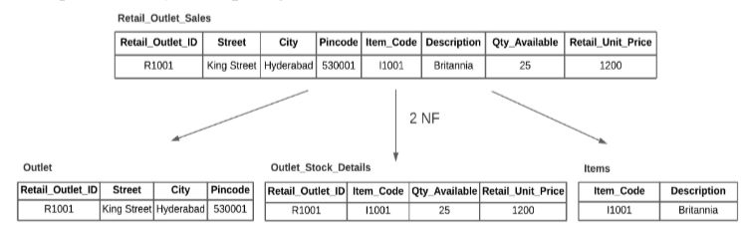

**Third Normal Form (3NF):** 3NF introduces the requirement that no non-key attribute should be

functionally determined by another non-key attribute or set of non-key attributes. This means

there should be no transitive dependency on the primary key. To attain 3NF, relation

decomposition is extended to establish new relations containing non-key attributes that

functionally determine other non-key attributes, thereby removing dependencies that do not rely

solely on the primary key. A relation achieves 3NF status when it satisfies 2NF conditions, and

non-key attributes do not depend on any other non-key attribute.

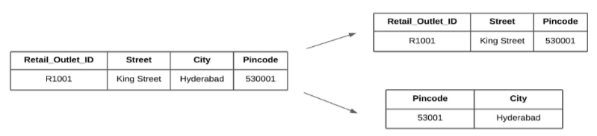

### 4.4.3 Sanitization

Data sanitization is the process of removing any illegal characters or values from data. In web

applications, sanitizing user input is a common task to prevent security vulnerabilities. PHP

provides a built-in filter extension that can be used to sanitize and validate various types of external input such as email addresses, URLs, IP addresses, and more. These filters are designed to make data sanitization easier and faster. For example, the PHP filter extension has a function that can remove all characters except letters, digits, and certain special characters (!#$%&’*+-

=?_`{|}~@.[]), as specified by a flag.

Web applications often receive external input from various sources, including user input from

forms, cookies, web services data, server variables, and database query results. It is important to

sanitize all external input to ensure that it is safe and does not contain any malicious code or values.

**4.4.4 Indexing**

Indexing, in the context of databases and data storage, is the process of creating a data structure (an index) to optimize the retrieval of specific data from a larger dataset. Indexes are used to improve the speed and efficiency of data retrieval operations by providing a quick lookup mechanism for specific columns or fields in a database table. They work like an organized reference to data, allowing the database management system (DBMS) to quickly locate the rows that match a given search criteria without the need to scan the entire dataset. Here are some key points about indexing:

1. **Data Retrieval Optimization**: The primary purpose of indexing is to speed up data retrieval operations, such as searching for records that meet certain criteria or filtering data based on specific columns. Without indexes, these operations might require scanning the entire dataset, which can be slow and resource-intensive for large datasets.
2. **Indexed Columns**: Indexes are created on specific columns of a database table. Typically, these columns are the ones frequently used in search conditions (e.g., in WHERE clauses of SQL queries). Indexes are not created on all columns, only on those where the benefit of faster data retrieval justifies the additional storage and maintenance overhead.
3. **Data Structure**: An index is a data structure that contains a sorted or hashed copy of a subset of the data from the indexed column, along with a pointer to the actual data row. The data in the index is organized to facilitate quick lookups.
4. **Types of Indexes**: There are various types of indexes, including B-tree (balanced tree) indexes, hash indexes, bitmap indexes, and more. Each type has its advantages and is suitable for specific use cases.
5. **Maintenance**: Indexes need to be maintained as data in the table changes. This means that when you add, update, or delete rows, the corresponding changes must also be reflected in the indexes. Therefore, there is a trade-off between the benefits of faster data retrieval and the overhead of index maintenance.
6. **Unique and Non-Unique Indexes**: Some indexes enforce uniqueness, meaning that the indexed column's values must be unique across all rows. Other indexes allow duplicate values in the indexed column.
7. **Clustered and Non-clustered Indexes**: In some database systems, you may come across the concept of clustered and non-clustered indexes. A clustered index determines the physical order of data in a table, while non-clustered indexes are separate data structures used for quicker data retrieval.
8. **Composite Indexes**: In cases where you frequently search based on multiple columns, you can create composite indexes that include multiple columns in a single index.

### 4.5 TABLE DESIGN

**1. User**

Primary Key: **user_id**

|  |  |  |  |  |
| --- | --- | --- | --- | --- |
| **No:** | **Field name** | **Datatype (Size)** | **Key Constraints** | **Description of the field** |
| 1 | user_id | AutoField | Primary Key (PK) | Primary Key of the user. |
| 2 | email | EmailField | unique=True | Email address of the user. |
| 3 | username | CharField | Not Null | Username of the user. |
| 4 | first_name | CharField | Not Null | First name of the user. |
| 5 | last_name | CharField | Not Null | Last name of the user. |
| 6 | role | CharField | max_length=20 | User role (User, admin). |

**4. Feedback**

Primary Key: **feedback_id**

Foreign Key: **user** references table **User**

|  |  |  |  |  |
| --- | --- | --- | --- | --- |
| **No:** | **Field name** | **Datatype (Size)** | **Key Constraints** | **Description of the field** |
| 1 | feedback_id | IntegerField | Primary Key (PK) | Feedback ID |
| 2 | message | CharField | Not Null | Content |
| 3 | date | DateTimeField | Not Null | Date submitted |

**2. Complaint**

Primary Key: **complaint_id**

Foreign Key: **user** references table **User**

|  |  |  |  |  |
| --- | --- | --- | --- | --- |
| **No:** | **Field name** | **Datatype (Size)** | **Key Constraints** | **Description of the field** |
| 1 | complaint_id | AutoField | Primary Key (PK) | Complaint_ID |
| 2 | user | CharField | Foreign Key | Date of Birth |
| 3 | name | CharField | max_length=50 | Victim name |
| 4 | place | CharField | max_length=10 | Incident Location |
| 5 | description | CharField | max_length=25 | Complaint Description |
| 6 | evidence | ImageField | Not Null | Evidence photo |

**5. MissingPerson**

Primary Key: **missingperson_id**

Foreign Key: **user_id** references table **User**

|  |  |  |  |  |
| --- | --- | --- | --- | --- |
| **No:** | **Field name** | **Datatype (Size)** | **Key Constraints** | **Description of the field** |
| 1 | missingperson_id | AutoField | Primary Key (PK) | Missing person ID |
| 2 | user_id | IntegerField | ForeignKey(FK) | User ID |
| 3 | gender | CharField | Not Null | Gender |
| 4 | description | TextField | Not Null | Description |
| 5 | photo | ImageField | default=timezone.now | Image of missing person |
| 6 | status | CharField | Not Null | Status |
| 7 | age | IntegerField | Not Null | Age |

**6. Table: Social Media Primary key**: SMID

|  |  |  |
| --- | --- | --- |
| **Field** | **Type** | **Description** |
| SMID | INT | Unique identifier for the social media feed |
| AdminID | INT | ID of the admin who posted the feed |
| Content | TEXT | Text content of the feed |
| ImageURL | VARCHAR(255) | URL of any image attached to the feed |
| VideoURL | VARCHAR(255) | URL of any video attached to the feed |
| PostedAt | DATETIME | Date and time when the feed was posted |

**7. Table:Policestation**

**Primary key:user_id**

| **No** | **Field name** | **Datatype (Size)** | **Key Constraints** | **Description of the field** |
| --- | --- | --- | --- | --- |
| 1 | user_id | OneToOneField | Primary Key (PK) | User ID (related to User model) |
| 2 | station_id | CharField | Not Null | Station ID |
| 3 | first_name | CharField | Not Null | First name of the police officer |
| 4 | last_name | CharField | Not Null | Last name of the police officer |
| 5 | email | EmailField | Not Null | Email address |
| 6 | branch | CharField | Not Null | Branch or division of the police station |

# CHAPTER 5

# SYSTEM TESTING

* 1. **INTRODUCTION**

Software testing involves executing a software program in a controlled manner to determine if it behaves as intended, often using verification and validation methods. Validation involves evaluating a product to ensure it complies with specifications, while verification can involve reviews, analyses, inspections, and walkthroughs. Static analysis examines the software's source code to identify issues, while dynamic analysis examines its behavior during runtime to gather information like execution traces, timing profiles, and test coverage details. Testing involves a series of planned and systematic activities that start with individual modules and progress to the integration of the entire computer-based system.

The objectives of testing include identifying errors and bugs in the software, ensuring that the software functions according to its specifications, and verifying that it meets performance requirements. Testing can be performed to assess correctness, implementation efficiency, and computational complexity. A successful test is one that detects an undiscovered error, and a good test case has a high probability of uncovering such errors. Testing is crucial to achieving system testing objectives and can involve various techniques such as functional testing, performance testing, and security testing.

## TEST PLAN

A test plan is a document that outlines the required steps to complete various testing methodologies. It provides guidance on the activities that need to be performed during testing. Software developers create computer programs, documentation, and associated data structures. They are responsible for testing each component of the program to ensure it meets the intended purpose. To address issues with self-evaluation, an independent test group (ITG) is often established. Testing objectives should be stated in quantifiable language, such as mean time to failure, cost to find and fix defects, remaining defect density or frequency of occurrence, and test work-hours per regression test.

The different levels of testing include:

* Unit testing
* Integration testing
* Data validation testing
* Output testing

### Unit Testing

Unit testing is a software testing technique that focuses on verifying individual components or modules of the software design. The purpose of unit testing is to test the smallest unit of software design and ensure that it performs as intended. Unit testing is typically white-box focused, and multiple components can be tested simultaneously. The component-level design description is used as a guide during testing to identify critical control paths and potential faults within the module's perimeter.

During unit testing, the modular interface is tested to ensure that data enters and exits the software unit under test properly. The local data structure is inspected to ensure that data temporarily stored retains its integrity during each step of an algorithm's execution. Boundary conditions are tested to ensure that all statements in a module have been executed at least once, and all error handling paths are tested to ensure that the software can handle errors correctly. Before any other testing can take place, it is essential to test data flow over a module interface. If data cannot enter and exit the system properly, all other tests are irrelevant.

Another crucial duty during unit testing is the selective examination of execution pathways to anticipate potential errors and ensure that error handling paths are set up to reroute or halt work when an error occurs. Finally, boundary testing is conducted to ensure that the software operates correctly at its limits.

### Integration Testing

Integration testing is a systematic approach that involves creating the program structure while simultaneously conducting tests to identify interface issues. The objective is to construct a program structure based on the design that uses unit-tested components. The entire program is then tested. Correcting errors in integration testing can be challenging due to the size of the overall program, which makes it difficult to isolate the causes of the errors.

As soon as one set of errors is fixed, new ones may arise, and the process may continue in an apparently endless cycle. Once unit testing is complete for all modules in the system, they are integrated to check for any interface inconsistencies. Any discrepancies in program structures are resolved, and a unique program structure is developed.

### Validation Testing or System Testing

The final stage of the testing process involves testing the entire software system, including all forms, code, modules, and class modules. This is commonly referred to as system testing or black box testing. The focus of black box testing is on testing the functional requirements of the software. A software engineer can use this approach to create input conditions that will fully test each program requirement. The main types of errors targeted by black box testing include incorrect or missing functions, interface errors, errors in data structure or external data access, performance errors, initialization errors, and termination errors.

### Output Testing or User Acceptance Testing

User acceptance testing is performed to ensure that the system meets the business requirements and user needs. It is important to involve the end users during the development process to ensure that the software aligns with their needs and expectations. During user acceptance testing, the input and output screen designs are tested with different types of test data. The preparation of test data is critical to ensure comprehensive testing of the system. Any errors identified during testing are addressed and corrected, and the corrections are noted for future reference.

* + 1. **Automation Testing**

Automation testing is a software testing approach that employs specialized automated testing software tools to execute a suite of test cases. Its primary purpose is to verify that the software or equipment operates precisely as intended. Automation testing identifies defects, bugs, and other issues that may arise during product development.

While some types of testing, such as functional or regression testing, can be performed manually, there are numerous benefits to automating the process. Automation testing can be executed at any time of day and uses scripted sequences to evaluate the software. The results are reported, and this information can be compared to previous test runs. Automation developers typically write code in programming languages such as C#, JavaScript, and Ruby.

* + 1. **Selenium Testing**

Selenium is an open-source automated testing framework used to verify web applications across different browsers and platforms. Selenium allows for the creation of test scripts in various programming languages such as Java, C#, and Python. Jason Huggins, an engineer at Thought Works, developed Selenium in 2004 while working on a web application that required frequent testing. He created a JavaScript program called "JavaScriptTestRunner" to automate browser actions and improve testing efficiency. Selenium has since evolved and continues to be developed by a team of contributors.

In addition to Selenium, another popular tool used for automated testing is Cucumber. Cucumber is an open-source software testing framework that supports behavior-driven development (BDD). It allows for the creation of executable specifications in a human readable format called Gherkin. By using a common language, Cucumber facilitates effective communication and collaboration during the testing process. It promotes a shared understanding of the requirements and helps ensure that the developed software meets the intended business goals.

Cucumber can be integrated with Selenium to combine the benefits of both tools. Selenium is used for interacting with web browsers and automating browser actions, while Cucumber provides a structured framework for organizing and executing tests. This combination allows for the creation of end-to-end tests that verify the behavior of web applications across different browsers and platforms, using a business-readable and maintainable format.

**Test Case 1: User login**

**code**

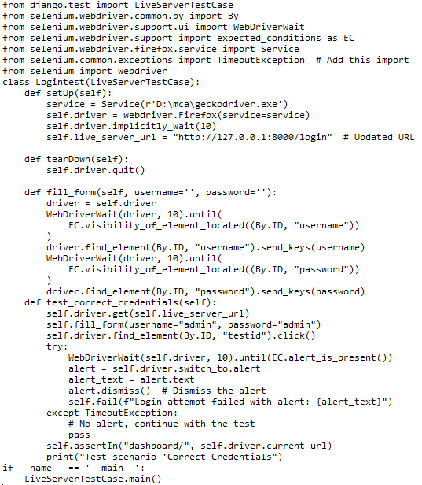

**Screenshot:**

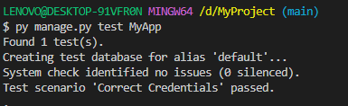

**Test Report:**

|  |  |  |  |  |  |
| --- | --- | --- | --- | --- | --- |
| **Test Case 1** | | | | | |
| **Project Name: ECHO** | | | | | |
| **Login Test Case** | | | | | |
| **Test Case ID: 1** | | | **Test Designed By: Sudeesh E S** | | |
| **Test Priority (Low/Medium/High): High** | | | **Test Designed Date: 16/04/2024** | | |
| **Module Name**: Login Screen | | | **Test Executed By: Ms. Nimmy Francis** | | |
| **Test Title:** Admin Login | | | **Test Execution Date: 16/04/2024** | | |
| **Description:** Verify login with valid username and password | | |  | | |
| **Pre-Condition:** User has valid username and password | | | | | |
| **Step** | **Test Step** | **Test Data** | **Expected Result** | **Actual Result** | **Status (Pass/**  **Fai l)** |
| 1 | Navigation to Login Page |  | Index features should be displayed | Login page displayed | Pass |
| 2 | Provide Valid username | User Name: admin | Admin should be able to Login | Admin Logged in and navigated to their corresponding Dashboard | Pass |
| 3 | Provide Valid Password | admin |
| 4 | Click on Login button |  |
| **Post-Condition:** Admin is validated with database and successfully login into account. The Account session details are logged in database. | | | | | |

**Test Case 2: View Users**

**Code**

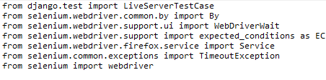

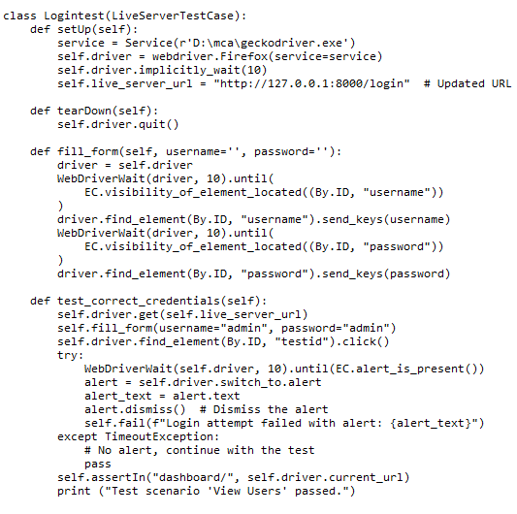

### Screenshot:

### 

### Test report:

|  |  |  |  |  |  |
| --- | --- | --- | --- | --- | --- |
| **Test Case 2** | | | | | |
| **Project Name: ECHO** | | | | | |
| **Search Test Case** | | | | | |
| **Test Case ID: 2** | | | **Test Designed By: Sudeesh E S** | | |
| **Test Priority (Low/Medium/High): High** | | | **Test Designed Date: 16/04/2024** | | |
| **Module Name**: User | | | **Test Executed By: Ms. Nimmy Francis** | | |
| **Test Title:** View Users | | | **Test Execution Date: 16/04/2023** | | |
| **Description:** Admin listing all users in the system | | |  | | |
| **Pre-Condition:** User has valid username and password | | | | | |
| **Step** | **Test Step** | **Test Data** | **Expected Result** | **Actual Result** | **Status (Pass/**  **Fai l)** |
| 1 | Navigation to Login Page |  | Index features should be displayed | Login page displayed | Pass |
| 2 | Provide Valid username | User Name: admin | user should be able to Login | user is Logged in and is navigated to their corresponding Dashboard | Pass |
| 3 | Provide Valid Password | admin |
| 4 | Click on Login button |  |
| 5 | Click on view users button | librarian | Show all users | users are displayed | Pass |
| **Post-Condition:** User is successfully logged into the system and user view is implemented. | | | | | |

### Test Case: 3

### Code

### 

### 

### 

### Screenshot:

### 

|  |  |  |  |  |  |
| --- | --- | --- | --- | --- | --- |
| **Test Case 4** | | | | | |
| **Project Name: ECHO** | | | | | |
| **Block User Test Case** | | | | | |
| **Test Case ID: 4** | | | **Test Designed By: Sudeesh E S** | | |
| **Test Priority(Low/Medium/High):High** | | | **Test Designed Date: 03/12/2023** | | |
| **Module Name**: View Companies | | | **Test Executed By: Ms. Nimmy Francis** | | |
| **Test Title:** View Companies | | | **Test Execution Date: 03/12/2023** | | |
| **Description:** Jobseeker can view the list of Companies. | | |  | | |
| **Pre-Condition:** Jobseeker has valid username and password | | | | | |
| **Step** | **Test Step** | **Test Data** | **Expected Result** | **Actual Result** | **Status (Pass/**  **Fai l)** |
| 1 | Navigation to Login Page |  | Index features should be displayed | Login page displayed | Pass |
| 2 | Provide Valid Jobseeker email address | User Name: sudeesh43 | User should be able to Login | User Logged in and navigated to their respective Dashboard | Pass |
| 3 | Provide Valid Password | Sushi@123 |
| 4 | Click on Login button |  |
| 5 | User is Navigated to dashboard |  | User should be able to view dashboard | User should be able to view his dashboard | Pass |
| 6 | User click File Complaints  Button |  | User should be able file a complaint | Complaint form displayed | Pass |
| 7 | Display Companies list |  | File complaint | Successfully filed complaint | Pass |
| **Post-Condition:** User successfully logged into their account and is able to file Complaints. | | | | | |

### Test Case 4: Police Login

### Code

### 

### 

### Screenshot:

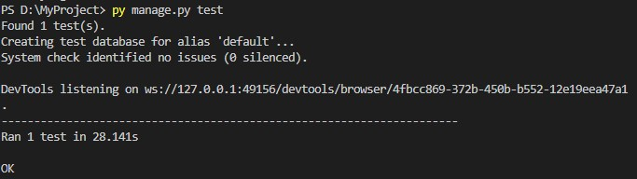

**Test report:**

|  |  |  |  |  |  |
| --- | --- | --- | --- | --- | --- |
| **Test Case 3** | | | | | |
| **Project Name: ECHO** | | | | | |
| **Search Test Case** | | | | | |
| **Test Case ID: 3** | | | **Test Designed By: Sudeesh E S** | | |
| **Test Priority (Low/Medium/High): High** | | | **Test Designed Date: 16/04/2024** | | |
| **Module Name**: Police Login | | | **Test Executed By: Ms. Nimmy Francis** | | |
| **Test Title:** Feedback | | | **Test Execution Date: 16/04/2024** | | |
| **Description:** Police user login | | |  | | |
| **Pre-Condition:** User has valid username and password | | | | | |
| **Step** | **Test Step** | **Test Data** | **Expect**  **Result** | **Actual Result** | **Status (Pass/**  **Fai l)** |
| 1 | Navigation to Login Page |  | Index features should be displayed | Login page displayed | Pass |
| 2 | Provide Valid user name | User Name: sudeesh | User should be able to Login | User Logged in and navigated to their corresponding Dashboard | Pass |
| 3 | Provide Valid Password | sushisan@234 |
| 4 | Click on Login button |  |
| 5 | Entering credentials in textbox | This is a test login | Log in | Login success | Pass |
| **Post-Condition:** User is logged into the system and successfully submitted the feedback form. | | | | | |

# CHAPTER 6

# IMPLEMENTATION

## INTRODUCTION

The implementation phase of a project is where the design is transformed into a functional system. It is a crucial stage in ensuring the success of the new system, as it requires gaining user confidence that the system will work effectively and accurately. User training and documentation are key concerns during this phase. Conversion may occur concurrently with user training or at a later stage. Implementation involves the conversion of a newly revised system design into an operational system. During this stage, the user department bears the primary workload, experiences the most significant upheaval, and has the most substantial impact on the existing system. Poorly planned or controlled implementation can cause confusion and chaos. Whether the new system is entirely new, replaces an existing manual or automated system, or modifies an existing system, proper implementation is essential to meet the organization's needs. System implementation involves all activities required to convert from the old to the new system. The system can only be implemented after thorough testing is done and found to be working according to specifications. System personnel evaluate the feasibility of the system. Implementation requires extensive effort in three main areas: education and training, system testing, and changeover. The implementation phase involves careful planning, investigating system and constraints, and designing methods to achieve changeover.

**6.2 IMPLEMENTATION PROCEDURES**

Software implementation is the process of installing the software in its actual environment and ensuring that it satisfies the intended use and operates as expected. In some organizations, the software development project may be commissioned by someone who will not be using the software themselves. During the initial stages, there may be doubts about the software, but it's important to ensure that resistance does not build up. This can be achieved by:

• Ensuring that active users are aware of the benefits of the new system, building their confidence in the software.

• Providing proper guidance to the users so that they are comfortable using the application.

Before viewing the system, users should know that the server program must be running on the server. Without the server object up and running, the intended process will not take place.

### User Training

User training is designed to prepare the user for testing and converting the system. To achieve

the objective and benefits expected from computer-based system, it is essential for the people who will be involved to be confident of their role in the new system. As system becomes more complex, the need for training is more important. By user training the user comes to know how to enter data, respond to error messages, interrogate the database and call up routine that will produce reports and perform other necessary functions.

* + 1. **Training on the Application Software**

After providing the necessary basic training on computer awareness, it is essential to provide training on the new application software to the user. This training should include the underlying philosophy of using the new system, such as the flow of screens, screen design, the type of help available on the screen, the types of errors that may occur while entering data, and the corresponding validation checks for each entry, and ways to correct the data entered. Additionally, the training should cover information specific to the user or group, which is necessary to use the system or part of the system effectively. It is important to note that this training may differ across different user groups and levels of hierarchy.

### System Maintenance

The maintenance phase is a crucial aspect of the software development cycle, as it is the time when the software is actually put to use and performs its intended functions. Proper maintenance is essential to ensure that the system remains functional, reliable, and adaptable to changes in the system environment. Maintenance activities go beyond simply identifying and fixing errors or bugs in the system. It may involve updates to the software, modifications to its functionalities, and enhancements to its performance, among other things. In essence, software maintenance is an ongoing process that requires continuous monitoring, evaluation, and improvement of the system to meet changing user needs and requirements.

**6.2.4 Hosting**

Echo is hosted on AWS, a reliable and affordable web hosting service. We chose AWS because it offers everything we need: an easy-to-use control panel, free SSL certificate for secure communication, and automatic backups to prevent data loss. With AWS, managing our hosting environment is a breeze, and our website operates smoothly and securely. This ensures that Echo delivers a great user experience while staying reliable and cost-effective.

**Amazon Web Services (AWS)**

AWS is a leading cloud computing platform offered by Amazon, providing a vast array of services that empower businesses and developers to innovate without the complexities of managing infrastructure. AWS offers on-demand, scalable, and pay-as-you-go services across computing, storage, networking, and more.

When it comes to hosting, AWS offers robust solutions tailored to various needs. The Elastic Compute Cloud (EC2) allows users to launch virtual servers, known as instances, with flexible compute capacity. Whether you require general-purpose, memory-optimized, or compute-optimized instances, EC2 has options to suit your workload. Alongside EC2, the Simple Storage Service (S3) provides scalable object storage ideal for hosting static websites, storing backups, or managing application data.

For database needs, AWS's Relational Database Service (RDS) simplifies the process of setting up, operating, and scaling relational databases like MySQL, PostgreSQL, and SQL Server. This service ensures efficient database management without the overhead of traditional setups. Additionally, AWS offers Elastic Load Balancing to distribute incoming traffic across multiple targets and Auto Scaling to automatically adjust the number of EC2 instances based on demand. Together, these features enable businesses to build resilient, scalable, and highly available applications in the AWS cloud.

**Procedure for hosting a website on pythonanywhere:**

**Step 1:** Sign Up and Create an Account

Go to the AWS Console website (amazonwebservices.com) and sign up for a new account.

**Step 2:** Access the Dashboard

**Step 3:** Set Up a new instance

**Step 4:** Clone Your Django Project from github

**Step 5:**

**Step 6:**

**Step 7:**

**Step 8:**

**Hosted Website:**

**Project link: http://65.0.91.166:8000/**

# CHAPTER 7

# CONCLUSION AND FUTURE SCOPE

## CONCLUSION

In conclusion, the "Online Crime Reporting System" named ECHO stands as a groundbreaking initiative in enhancing public safety and law enforcement collaboration within Kottayam district. Leveraging the powerful Django framework, ECHO provides a user-friendly web-based platform that empowers individuals to report criminal activities conveniently and efficiently. The project not only bridges the gap between the general public and law enforcement but also establishes a seamless process for reporting and addressing crimes. The system's key features, including user registration, incident reporting, and administrative interfaces for both users and admins, contribute to a comprehensive solution. By utilizing HTML and CSS for the front end and Python Django for the back end, ECHO ensures a secure, scalable, and intuitive experience for users of all technical backgrounds. ECHO aspires not only to meet but to exceed industry standards, contributing to a paradigm shift in how crimes are reported, managed, and addressed in the ever-evolving landscape of public safety.

* 1. **FUTURE SCOPE**

Anticipating the future, ECHO envisions a path of continuous innovation and evolution to navigate the dynamic landscape of online crime reporting. A pivotal focus for advancement lies in the strategic integration of artificial intelligence (AI) into the platform. Specifically, ECHO aims to introduce advanced features for enhancing the analysis of incident reports, automating the categorization of criminal activities, and providing law enforcement with more efficient tools for prioritization and management. Moreover, ECHO is poised to explore additional dimensions of multimedia handling. Enhancing the platform's capabilities to process and analyze multimedia evidence, such as photos and videos submitted by users, will contribute to a more comprehensive and efficient crime reporting system.

In alignment with a user-centric approach, ECHO remains committed to soliciting and incorporating user feedback. This iterative process ensures that the platform not only meets but exceeds the expectations of both the public and law enforcement. By staying abreast of technological advancements and responding proactively to user needs, ECHO positions itself as a frontrunner in redefining the landscape of online crime reporting, making it an indispensable tool for fostering community safety and collaboration.

# CHAPTER 8

# BIBLIOGRAPHY

### REFERENCES:

* Design and Implementation of Online Crime Reporting System, Joy I. Eze, Elijah O. Omidiora, Published in: International Journal of Computer Applications 2014.
* Crime Reporting and Criminal Identification Using Online Reporting System, Priya H. Patil, Mr. Aniket S. Potpote, International Journal of Advanced Research in Computer Engineering & Technology 2014.
* Secure and Efficient Online Crime Reporting System for Community Policing, Mohammed A. Aibinu, Mustafa Man, Rania A. Kora, Ali Selamat, Journal of Network and Computer Applications 2016.

### WEBSITES:

* + - [www.chat.openai.com](http://www.chat.openai.com)
    - www.djangoproject.com
    - www.github.com
    - www.glassdoor.com
    - www.google.com
    - www.hackerrank.com
    - www.indeed.com
    - www.monster.com
    - www.phind.ch
    - www.stackoverflow.com
    - [www.w3schools.com](http://www.w3schools.com)

# CHAPTER 9

# APPENDIX

## Sample Code

**Login**

{% load static %}

{% load socialaccount %}

{% block content %}

<html>

<head>

  <title>Login</title>

  <link rel="stylesheet" href="https://maxcdn.bootstrapcdn.com/bootstrap/4.5.2/css/bootstrap.min.css">

  <style>

    .image-container {

      background-size: cover;

      min-height: 100vh;

      display: flex;

      align-items: center;

      justify-content: center;

    }

    .form-container {

      background-color: white;

      padding: 20px;

      border-radius: 5px;

      box-shadow: 0px 0px 10px rgba(0, 0, 0, 0.2);

    }

    .image-container img {

      max-width: 100%;

      height: auto;

      display: block;

    }

  </style>

</head>

<body>

  <div class="container-fluid">

    <div class="row">

      <div class="col-md-6 image-container">

        <img src="https://img.freepik.com/free-vector/gifts-concept-illustration_114360-2256.jpg?size=626&ext=jpg&ga=GA1.2.1125696270.1689738632&semt=ais" alt="Image">

      </div>

      <div class="col-md-6">

        <div class="container form-container mt-5">

          <h1>Login</h1>

          {% for messages in messages %}

            <h3 style="color: red">{{ messages }}</h3>

            {% endfor %}

          <form id="loginForm" action="#" method="POST">

            {% csrf_token %}

            <div class="form-group">

              <label for="email">Email:</label>

              <input class="form-control" id="email" name="email" >

              <small id="emailError" class="form-text text-danger"></small>

            </div>

            <div class="form-group">

              <label for="password">Password:</label>

              <input type="password" class="form-control" id="password" name="password" required>

              <small id="passwordError" class="form-text text-danger"></small>

            </div>

            <button type="submit" class="btn btn-primary" id="submit">Login</button>

          </form>

          <p class="mt-3">Or</p>

          <a href="{% provider_login_url 'google'%}?next=/" class="btn btn-primary btn-block mt-3" onclick="signInWithGoogle()">

            <span class="align-middle">

              <img src="https://cdn-icons-png.flaticon.com/512/281/281764.png?w=740&t=st=1691744655~exp=1691745255~hmac=05990f95cf17e4c6378ea22d0d190f708342a8954403cb069955a97e2c0fd10c" alt="Google Icon" width="24" height="24">

            </span>

            <span class="align-middle ml-2">Sign in with Google</span>

          </a>

          <div class="mt-3">

            <p>Don't have an account yet? <a href="{% url 'register' %}">Sign up</a></p>

          </div>

        </div>

      </div>

    </div>

  </div>

  {% endblock %}

  <script src="https://code.jquery.com/jquery-3.5.1.slim.min.js"></script>

  <script src="https://cdn.jsdelivr.net/npm/@popperjs/core@2.9.3/dist/umd/popper.min.js"></script>

  <script src="https://maxcdn.bootstrapcdn.com/bootstrap/4.5.2/js/bootstrap.min.js"></script>

</body>

</html>

**Registration**

<!DOCTYPE html>

<html>

<head>

  <title>Sign Up</title>

  <link rel="stylesheet" href="https://maxcdn.bootstrapcdn.com/bootstrap/4.5.2/css/bootstrap.min.css">

  <style>

    .image-container {

    background-size: cover;

    min-height: 100vh;

    display: flex;

    align-items: center;

    justify-content: center;

  }

  .form-container {

    background-color: white;

    padding: 20px;

    border-radius: 5px;

    box-shadow: 0px 0px 10px rgba(0, 0, 0, 0.2);

  }

  .image-container img {

    max-width: 100%;

    height: auto;

    display: block;

  }

</style>

</head>

<body>

  <div class="container-fluid">

    <div class="row">

      <div class="col-md-6 image-container">

        <img src="https://img.freepik.com/free-vector/gifts-concept-illustration_114360-2256.jpg?size=626&ext=jpg&ga=GA1.2.1125696270.1689738632&semt=ais" alt="Image">

      </div>

      <div class="col-md-6">

        <div class="container form-container mt-5">

          <h1>Sign Up</h1>

          {% for messages in messages %}

            <h3 style="color: red">{{ messages }}</h3>

            {% endfor %}

          <form method="post" action="#" id="registrationForm" enctype="multipart/form-data">

            {% csrf_token %}

            <div class="form-group">

              <label for="username">Name:</label>

              <input type="text" class="form-control" id="name" name="username" required>

              <small id="usernameError" class="form-text text-danger"></small>

            </div>

            <div class="form-group">

              <label for="email">Email:</label>

              <input type="email" class="form-control" id="email" name="email" required>

              <small id="emailError" class="form-text text-danger"></small>

            </div>

            <div class="form-group">

              <label for="phoneNumber">Phone Number:</label>

              <input type="tel" class="form-control" id="phoneNumber" name="mobile" required>

              <small id="phoneNumberError" class="form-text text-danger"></small>

            </div>

            <div class="form-group">

              <label for="password">Password:</label>

              <input type="password" class="form-control" id="password" name="password" required>

              <small id="passwordError" class="form-text text-danger"></small>

            </div>

            <div class="form-group">

              <label for="confirmPassword">Confirm Password:</label>

              <input type="password" class="form-control" id="confirmPassword" name="confirmPassword" required>

              <small id="confirmPasswordError" class="form-text text-danger"></small>            </div>

            <div>

              <p>Want to be a Seller</p>

              <input type="radio" id="customer" name="user_role" value="customer" checked>

              <label for="customer">No</label>

              <input type="radio" id="staff" name="user_role" value="staff">

              <label for="staff">Yes</label>

            </div>

            <div class="form-group" id="certificationImageField" style="display: none;">

              <label for="certification_image">Certification Image:</label>

              <input type="file" class="form-control" id="certification_image" name="certification_image">

              <small id="certificationImageError" class="form-text text-danger"></small>

            </div>

            <button type="submit" class="btn btn-primary">Register</button>

            <div class="mt-3">

              <p>Already have an account? <a href="{% url 'login_page' %}">Login</a></p>

            </div>

          </form>

      </div>

    </div>

  </div>

</div>

  <!-- Add Bootstrap JS and jQuery scripts -->

  <script src="https://code.jquery.com/jquery-3.5.1.slim.min.js"></script>

  <script src="https://cdn.jsdelivr.net/npm/@popperjs/core@2.9.3/dist/umd/popper.min.js"></script>

  <script src="https://maxcdn.bootstrapcdn.com/bootstrap/4.5.2/js/bootstrap.min.js"></script>

  <script>

    const sellerRadio = document.getElementById('staff');

const certificationImageField = document.getElementById('certificationImageField');

sellerRadio.addEventListener('change', function () {

  if (sellerRadio.checked) {

    certificationImageField.style.display = 'block';

  } else {

    certificationImageField.style.display = 'none';

  }

});

  </script>

  <script>

    const registrationForm = document.getElementById('registrationForm');

    const nameInput = document.getElementById('name');

    const nameError = document.getElementById('usernameError');

    const emailInput = document.getElementById('email');

    const phoneNumberInput = document.getElementById('phoneNumber');

    const passwordInput = document.getElementById('password');

    const confirmPasswordInput = document.getElementById('confirmPassword');

    const certificationImageInput = document.getElementById('certification_image');

    const certificationImageError = document.getElementById('certificationImageError');

  function validateName() {

  const nameValue = nameInput.value;

  // Regular expression to check if the name contains only alphabets and starts with a capital letter

  const namePattern = /^[A-Z][a-zA-Z]*$/;

  if (!namePattern.test(nameValue)) {

    nameError.textContent = 'Name should start with a capital letter and contain only alphabets.';

    return false;

  } else {

    nameError.textContent = '';

    return true;

  }

}

    function validateEmail() {

      const emailValue = emailInput.value;

      const emailError = document.getElementById('emailError');

      if (!/^\S+@\S+\.\S+$/.test(emailValue)) {

        emailError.textContent = 'Enter a valid email address.';

        return false;

      } else {

        emailError.textContent = '';

        return true;

      }

    }

    function validatePhoneNumber() {

      const phoneNumberValue = phoneNumberInput.value;

      const phoneNumberError = document.getElementById('phoneNumberError');

      if (!/^[6-9]\d{9}$/.test(phoneNumberValue)) {

        phoneNumberError.textContent = 'Enter a valid  phone number.';

        return false;

      } else {

        phoneNumberError.textContent = '';

        return true;

      }

    }

    function validatePassword() {

      const passwordValue = passwordInput.value;

      const passwordError = document.getElementById('passwordError');

      if (!/(?=.*\d)(?=.*[a-z])(?=.*[A-Z])(?=.*\W).{8,}/.test(passwordValue)) {

        passwordError.textContent = 'Password should contain at least 8 characters, one uppercase letter, one lowercase letter, one number, and one special character.';

        return false;

      } else {

        passwordError.textContent = '';

        return true;

      }

    }

    function validateConfirmPassword() {

      const confirmPasswordValue = confirmPasswordInput.value;

      const confirmPasswordError = document.getElementById('confirmPasswordError');

      if (confirmPasswordValue !== passwordInput.value) {

        confirmPasswordError.textContent = 'Passwords do not match.';

        return false;

      } else {

        confirmPasswordError.textContent = '';

        return true;

      }

    }

  function validateCertificationImage() {

  const certificationImageValue = certificationImageInput.value;

  const allowedExtensions = ['.jpg', '.jpeg', '.png'];

  const extension = certificationImageValue.substring(certificationImageValue.lastIndexOf('.') + 1).toLowerCase();

  if (!allowedExtensions.includes(`.${extension}`)) {

    certificationImageError.textContent = 'File format must be JPEG, PNG, or JPG.';

    return false;

  } else {

    certificationImageError.textContent = '';

    return true;

  }

}

    nameInput.addEventListener('blur', validateName);

    emailInput.addEventListener('keyup', validateEmail);

    phoneNumberInput.addEventListener('keyup', validatePhoneNumber);

    passwordInput.addEventListener('keyup', validatePassword);

    confirmPasswordInput.addEventListener('keyup', validateConfirmPassword);

    certificationImageInput.addEventListener('change', validateCertificationImage);

    // Validate on form submit

    registrationForm.addEventListener('submit', function(event) {

     // const isUsernameValid = validateUsername();

      const isEmailValid = validateEmail();

      const isPhoneNumberValid = validatePhoneNumber();

      const isPasswordValid = validatePassword();

      const isConfirmPasswordValid = validateConfirmPassword();

      if (!isEmailValid || !isPasswordValid || !isConfirmPasswordValid) {

        event.preventDefault();

      }

    });

    document.querySelector('a[href="#"]').addEventListener('click', function(event) {

      event.preventDefault();

    });

  </script>

</body>

</html>

**Product List page**

    {% load static %}

    <!Doctype html>

        <html lang="en">

        <head>

            <meta charset="utf-8">

            <meta name="viewport" content="width=device-width, initial-scale=1, shrink-to-fit=no">

            <title> CraftedEuphoria</title>

            <link rel="shortcut icon" href="{% static 'assets/images/fav.png' %}" type="image/x-icon">

            <link href="https://fonts.googleapis.com/css2?family=Poppins:wght@300;400;500;600;700;800;900&amp;display=swap" rel="stylesheet">

            <link rel="shortcut icon" href="{% static 'assets/images/fav.jpg' %}">

            <link rel="stylesheet" href="{% static 'assets/css/bootstrap.min.css' %}">

            <link rel="stylesheet" href="https://cdn.jsdelivr.net/npm/bootstrap-icons@1.7.2/font/bootstrap-icons.css">

            <link rel="stylesheet" type="text/css" href="{% static 'assets/css/style.css' %}"/>

            <link rel="stylesheet" href="https://cdnjs.cloudflare.com/ajax/libs/font-awesome/4.7.0/css/font-awesome.min.css">

            <style>

                .product-box {

                    height: 100%; /* Set a fixed height for the box */

                }

                .product-image {

                    width: 100%; /* Set a fixed width for the image */

                    height: 200px; /* Set a fixed height for the image */

                    object-fit: cover; /* Maintain aspect ratio and cover the entire space */

                }

            </style>

        </head>

        <body>

            <header class="container-fluid bg-white">

                <div class="header-top bg-gray  border-bottom">

                    <div class="container">

                        <div class="row">

                            <div class="col-md-8">

                                <ul class="d-inline-flex pt-0 pt-md-2 fs-6">

                                </ul>

                            </div>

                            <div class="col-md-4 d-flex align-items-end">

                                <ul class="ms-auto d-inline-flex">

                                    {% if user.is_authenticated %}

                                    <li class="p-2"><a target="_blank" href="{% url 'loggout' %}"><button class="btn px-4 btn-danger">Logout</button></a></li>

                                    <li class="p-2"><a target="_blank" href="{% url 'userprofile' %}"><button class="btn px-4 btn-danger">User Profile</button></a></li>

                                    {% else %}

                                    <li class="p-2"><a target="_blank" href="{% url 'login_page' %}"><button class="btn px-4 btn-danger">Login</button></a></li>

                                    <li class="p-2"><a target="_blank" href="{% url 'register' %}"><button class="btn px-4 btn-outline-danger">Sign Up</button></a></li>

                                    {% endif %}

                                </ul>

                            </div>

                        </div>

                    </div>

                </div>

                <header>

                    <div class="logo-container p-2">

                    <div class="container">

                        <div class="row">

                            <div class="col-md-3 col-9 pt-1 pb-2">

                                    <img class="logo" src="{% static 'assets/images/logo.png' %}" alt="logo" style="width:165px;height:45px;">

                            </div>

                            <div class="col-md-6 d-none d-md-block pt-2">

<div class="row">

    <div class="col-md-12">

        <form id="search-form" method="GET" action="{% url 'search_product' %}">

            <div class="input-group">

                <input type="text" class="form-control" name="productname" id="productname" placeholder="Search by Product Name" oninput="toggleSearchButton()">

                <div class="input-group-append">

                    <button class="btn btn-primary" id="search-button" type="submit" disabled><i class="fa fa-search"></i> </button>

                </div>

            </div>

        </form>

    </div>

</div>

<script>

    function toggleSearchButton() {

        const productNameInput = document.getElementById("productname");

        const searchButton = document.getElementById("search-button");

        if (productNameInput.value.trim() === "") {

            searchButton.disabled = true;

        } else {

            searchButton.disabled = false;

        }

    }

</script>

                            </div>

                            <div class="col-md-3 col-3 pt-1 text-end">

                                <a href="{% url 'cart' %}">

                                    <button type="button" class="btn btn-light shadow-md border position-relative">

                                        <i class="bi fs-4 bi-basket"></i>

                                    </button>

                                </a>

                                <button type="button" class="btn d-none d-md-inline-block ms-3 btn-light shadow-md border position-relative">

                                    <i class="bi fs-4 bi-heart"></i>

                                </button>

                            </div>

                        </div>

                    </div>

                </div>

                    <div class="menu-bar bg-danger container-fluid border-top">

                        <div class="container">

                            <h6 class="d-md-none text-white p-3 mb-0 fw-bold">Menu

                                <a class="text-white" data-bs-target="#menu" data-bs-toggle="collapse" aria-expanded="false" aria-controls="menu"><i class="bi cp bi-list float-end fs-1 dmji"></i></a>

                            </h6>

                            <ul id="menu" class="navcol fw-bold d-none d-md-inline-flex">

                                <li class="p-21 px-4">

                                    <a class="text-white" href="">Categories<i class="bi pt-2 bi-chevron-down"></i></a>

                                    <div class="inner-div">

                                        <ul class="">

                                            <li><a href="{% url 'products_list' category_id=8 %}">Birthday Gifts</a></li>

                                            <li><a href="{% url 'products_list' category_id=4 %}">Anniversary Gifts</a></li>

                                            <li><a href="{% url 'products_list' category_id=7 %}">Special Occasion</a></li>

                                            <li><a href="{% url 'products_list' category_id=3 %}">Festive Special Gifts</a></li>

                                            <li><a href="{% url 'products_list' category_id=5 %}">Customized Gifts</a></li>

                                        </ul>

                                    </div>

                                </li>

                                <li class="p-21 px-4 active"><a class="text-white" href="{% url 'index' %}">Home </a></li>

                                <li class="p-21 px-4"><a class="text-white" href="{% url 'about' %}">About Us </a></li>

                            </ul>

                        </div>

                    </div>

                </header>

    </header>

    <div class="row mt-5">

        {% for product in products %}

        <div class="col-lg-3 col-md-4 mb-4">

            <div class="product-box bg-white p-2 shadow-md">

                <div class="text-center">

                    <a href="">

                        <img class="product-image" src="{{ product.image.url }}" alt="{{ product.name }}"   >

                    </a>

                </div>

                <div class="detail p-2">

                    <h4 class="mb-1 fs-5 fw-bold">{{ product.name }}</h4>

                    <h4 class="mb-1 fs-5">{{ product.description }}</h4>

                    <b class="fs-4 text-danger">${{ product.price }}</b>

                    <ul class="mt-0 vgth">

                        <li class="fs-8">

                        </li>

                        <li class="float-end gvi">

                            <i class="bi text-danger bi-heart-fill"></i>

                        </li>

                    </ul>

                    <div class="row pt-2">

                        <div class="col-md-6">

                            <a href="{% url 'product_detail' product.id %}">

                                <button class="btn mb-2 fw-bold w-100 btn-danger">Buy Now</button>

                            </a>

                        </div>

                        <div class="col-md-6">

                            <!-- Add to Cart Form -->

                            <form method="post">

                                {% csrf_token %}

                                <!-- Add a hidden input for the product ID -->

                                <input type="hidden" name="product_id" value="{{ product.id }}">

                                <!-- Product Name (Hidden Input) -->

                                <input type="hidden" name="product_name" value="{{ product.name }}">

                                <!-- Product Price (Hidden Input) -->

                                <input type="hidden" name="product_price" value="{{ product.price }}">

                                <!-- Quantity Input -->

                                <input type="number" name="quantity" value="1" min="1">

                                <!-- Add to Cart Button -->

                                <button type="submit" class="btn mb-2 fw-bold w-100 btn-outline-danger">Add to Cart</button>

                            </form>

                        </div>

                    </div>

                </div>

            </div>

        </div>

        {% endfor %}

    </div>

    </body>

    </html>

**Add to Cart**

 {% load static %}

<!DOCTYPE html>

<html lang="en">

<head>

    <meta charset="UTF-8">

    <title>Cart</title>

    <style>

        body {

            font-family: Arial, sans-serif;

            background-color: #f0f0f0;

            margin: 0;

            padding: 0;

        }

        .cart-container {

            background-color: #fff;

            margin: 20px auto;

            padding: 20px;

            width: 80%;

            border-radius: 10px;

            box-shadow: 0 0 10px rgba(0, 0, 0, 0.2);

        }

        h1 {

            background-color: #333;

            color: #fff;

            padding: 20px;

            margin: 0;

            text-align: center;

        }

        ul {

            list-style: none;

            padding: 0;

        }

        li {

            background-color: #f9f9f9;

            margin: 10px 0;

            padding: 10px;

            border: 1px solid #ddd;

            border-radius: 5px;

            box-shadow: 0 2px 5px rgba(0, 0, 0, 0.1);

            display: flex;

            justify-content: space-between;

            align-items: center;

        }

        .product-image {

            width: 100px;

            height: 100px;

            margin-right: 10px;

        }

        .quantity {

            display: flex;

            align-items: center;

        }

        .quantity button {

            background-color: #333;

            color: #fff;

            border: none;

            padding: 5px 10px;

            margin: 0 5px;

            border-radius: 5px;

            cursor: pointer;

        }

        a {

            display: inline-block;

            background-color: #333;

            color: #fff;

            text-decoration: none;

            padding: 10px 20px;

            margin-top: 20px;

            border-radius: 5px;

            transition: background-color 0.3s ease;

        }

        a:hover {

            background-color: #555;

        }

    </style>

</head>

<body>

<!-- cart.html -->

<a href="{% url 'index' %}">Continue Shopping</a>

<div class="cart-container">

    <h1>Cart</h1>

    <ul>

        {% if cart_items %}

            {% for item in cart_items %}

                {% if item.status == 1 %}

            <li>

                <div>

                    <img src="{{ item.product.image.url }}" alt="{{ item.product.name }}" style="width:185px;height:125px;">

                    {{ item.product.name }} - Price: ${{ item.product.price }}

                </div>

                <div class="quantity">

                    <!-- {% for product_id, item in cart.items %}

                     <p>{{ item.name }} - ${{ item.price }} (Quantity: {{ item.quantity }})

                         <a href="{% url 'remove_from_cart' product_id %}">Remove</a></p>

                    {% endfor %} -->

                    <button onclick="decrementQuantity('{{ item.id }}', {{ item.product.price }})   ">-</button>

                    <span id="quantity_{{ item.id }}">{{ item.quantity }}</span>

                    <button onclick="incrementQuantity('{{ item.id }}', {{ item.product.price }})">+</button>

                    <a href="{% url 'remove_from_cart' item.product.id %}">Remove</a>

                </div>

            </li>

            {% endif %}

            {% endfor %}

        {% else %}

            <li>

                <p>Your cart is empty.</p>

            </li>

        {% endif %}

    </ul>

    <div id="total-price">Total Price: ${{ total_price }}</div>

    <a href="{% url 'billing' user_id=request.user.id %}">Checkout</a>

</div>

    <script>

    var totalPrice = {{ total_price }};

    function incrementQuantity(productId, price) {

        var quantityElement = document.getElementById('quantity_' + productId);

        var currentQuantity = parseInt(quantityElement.textContent);

        currentQuantity++;

        quantityElement.textContent = currentQuantity;

        updateTotalPrice(price);

    }

    function decrementQuantity(productId, price) {

        var quantityElement = document.getElementById('quantity_' + productId);

        var currentQuantity = parseInt(quantityElement.textContent);

        if (currentQuantity > 1) {

            currentQuantity--;

            quantityElement.textContent = currentQuantity;

            updateTotalPrice(-price);

        }

    }

    function updateTotalPrice(priceChange) {

        totalPrice += priceChange;

        var totalElement = document.getElementById('total-price');

        totalElement.textContent = 'Total Price: $' + totalPrice.toFixed(2);

    }

    function remove_from_cart(productId, price) {

        var quantityElement = document.getElementById('quantity_' + productId);

        var currentQuantity = parseInt(quantityElement.textContent);

        var listItem = quantityElement.parentElement.parentElement;

        listItem.remove();

        updateTotalPrice(-price * currentQuantity);

        var cartList = document.querySelector('ul');

        if (cartList.children.length === 0) {

            cartList.innerHTML = '<li><p>Your cart is empty.</p></li>';

        }

    }

</script>

</body>

</html>

**Payment**

 {% load static %}

<!DOCTYPE html>

<html lang="en">

<head>

    <meta charset="UTF-8">

    <meta name="viewport" content="width=device-width, initial-scale=1.0">

    <title>Payment Details</title>

    <style>

        /* Reset some default styles */

        body, h1, form {

            margin: 0;

            padding: 0;

        }

        body {

            font-family: Arial, Helvetica, sans-serif;

            background-color: #f2f2f2;

        }

        h1 {

            text-align: center;

            margin-top: 20px;

            color: #333;

        }

        form {

            background-color: #fff;

            max-width: 400px;

            margin: 0 auto;

            padding: 20px;

            border-radius: 5px;

            box-shadow: 0px 0px 10px rgba(0, 0, 0, 0.1);

        }

        label {

            font-weight: bold;

        }

        input[type="text"] {

            width: 100%;

            padding: 10px;

            margin-bottom: 10px;

            border: 1px solid #ccc;

            border-radius: 5px;

            font-size: 16px;

        }

        button[type="submit"] {

            display: block;

            width: 100%;

            padding: 10px;

            background-color: #007BFF;

            color: #fff;

            border: none;

            border-radius: 5px;

            font-size: 18px;

            cursor: pointer;

            transition: background-color 0.3s;

        }

        button[type="submit"]:hover {

            background-color: #0056b3;

        }

        .container {

  position: relative;

  padding: 20px; /* Add padding around the container as needed */

}

.cart-link-box {

  position: absolute;

  top: 10px;

  left: 10px;

  background-color: black; /* Background color for the box */

  color: white; /* Text color */

  padding: 10px 20px; /* Padding inside the box */

  border: 1px solid #333; /* Border for the box */

  border-radius: 5px; /* Rounded corners */

}

    </style>

</head>

<body>

<div class="container">

  <div class="cart-link-box">

    <a href="{% url 'cart' %}" style="color: white; text-decoration: none;">Back to Cart</a>

  </div>

       <h1>Payment Details</h1>

    <form action="{% url 'billing' user_id=request.user.id %}" method="POST">

    {% csrf_token %}

        <!-- Billing Information -->

        <h2>Billing Address</h2>

        <label for="billing_name">Name:</label>

        <input type="text" id="billing_name" name="name" placeholder=" Name" value="{{ user.userprofile.name }}" required>

        <br>

        <label for="billing_address">Address:</label>

        <input type="text" id="billing_address" name="address" placeholder=" Address" value="" required>

        <br>

        <label for="billing_city">Town:</label>

        <input type="text" id="billing_city" name="town" placeholder=" Town" value="" required>

        <br>

        <label for="billing_zip">ZIP Code:</label>

        <input type="text" id="billing_zip" name="zip_code" placeholder=" ZIP Code" value="" required>

        <br>

        <!-- Amount -->

        <h2>Amount</h2>

        <!-- Show the amount here (e.g., dynamically from your server-side code) -->

        <p>{{ total_price }}</p>

        <!-- Submit Button -->

        <button type="submit">Submit Payment</button>

    </form>

</body>

</html>

## Screen Shots

## 

## *Fig 1: Login Page*

## 

## *Fig 2: Registration Page*

## 

## *Fig 3: Index Page*

## 

## *Fig 4: Product List Page*

## 

## *Fig 5: Add to Cart Page*

## 

## *Fig 6: Payment Details Page*

## 

## *Fig 7: Payment Details Page*